Table of Content:

Table of Figures iv
List of Tables: v
1 Introduction 2
2 An Overview MPEG-1 Audio Layer-3 3
2.1 Introduction 3
2.2 MPEG Layer-3 Audio Features 4
2.2.1 Bit Reservoir 5
2.2.2 Audio Channel Modes 6
2.2.3 Sampling frequency 6
2.2.4 Bit-rate 6
2.2.5 Cyclic Redundancy Check (CRC) 7
2.2.6 Others 7
2.3 MP3 Encoding Algorithm 7
2.3.1 Filter bank 8
2.3.2 Perceptual model 8
2.3.3 Quantisation and Coding 8
2.3.4 Bit-stream Encoding 9
2.3.5 Factors determining encoder quality 9
2.4 MP3 Decoding Algorithm 10
2.4.1 Decoding of bit-stream 10
2.4.2 Inverse Quantisation 10
2.4.3 Synthesis Filter-bank 10
2.5 Generating the Output Sound 11
2.5.1 Digital to Analogue Conversion 11
2.5.2 Amplifier 13
2.6 Conclusion and Summary 13
3 MP3 Encoder selection: 14
3.1 The Criteria & Justification: 14
3.1.1 Bit-Rate encoding: 14
3.1.2 Fixed-point: 14
3.1.3 Open Source 15
3.1.4 Sound quality: 15
3.2 Candidate Encoders: 15
3.3 Independent Test Results, Methods and Test data: 15
3.4 Public domain usage: 16
3.5 Conclusion: 18
4 Cryptography 19
4.1 Walkthrough 19
4.2 Summary 19
5 User Interface Analysis and Design 20
5.1 What is a “User Interface?” 20
5.2 Concept of User Interface Design 20
5.2.1 Intuitiveness 20
5.2.2 Consistency 21
5.2.3 Simplicity 21
5.2.4 Prevention 21
5.2.5 Forgiveness 22
5.2.6 Aesthetics 22
5.3 DEEP-3 User Interface Overview 22
6 System Architecture 25
7 Processor Core Design 28
7.1 Introduction 28
7.2 Hardware Overview 28
7.2.1 Why RISC? 29
7.2.2 Harvard Architecture 29
7.2.3 Memory Banks 29
7.2.4 Registers 30
7.3 MIPS 30
7.4 Development Process 30
7.4.1 C Source Code 31
7.4.2 Profiling 31
7.4.3 Static Analysis 31
7.4.4 GCC 31
7.4.5 Simulation 32
7.4.6 Further Instruction Set Analysis 32
7.4.7 Changes & Optimisations 32
8 Hardware /Software Partitioning Design 33
8.1 Walkthrough: 33
8.2 Profiling: 35
8.3 Hardware/Software Partitioning: 35
8.4 Hardware/Software Scheduling: 35
9 Conclusion and Summary: 37
Appendices: 38
10 Appendix A - Performance Measurement 38
10.1 The need for performance measurement 38
10.2 Performance measurement Methods and techniques 39
10.3 Hardware Related: 39
10.3.1 Instruction mix: 39
10.4 System Effectiveness 40
10.4.1 Throughput: 40
10.4.2 Relative throughput: 40
10.4.3 Capability (capacity): 41
10.4.4 Turnaround time: 41
10.4.5 Availability: 41
10.5 Performance analysis tools 41
10.5.1 Microsoft Visual C++ 6.0 Profiler: 41
10.5.2 HiProf 1.01: 42
10.5.3 Visual Quantify: 42
10.6 Developing Optimised Code with Microsoft Visual C++ 6.0 43
10.6.1 Speed Optimisations 43
10.6.1.1 Changing the order of execution: 43
10.6.1.2 Copy propagation and dead store elimination: 44
10.6.1.3 Improving loop invariant: 44
10.6.1.4 Variable location: 44
10.6.1.5 Loop unrolling: 44
10.6.1.6 Instruction Order: 44
10.6.1.7 Dual pipeline considerations: 45
10.6.2 Size Optimisations 45
10.6.3 Other optimisation methods: 45
11 Appendix B: MP3 file header 46
12 Appendix C: Music clips for test the MP3 encoder 50
12.1.1 Test Data 50
12.1.2 Test results 50
13 References 52

Table of Figures

Figure 2-1: The MP3 frame header represented visually [1,2] 4
Figure 2-2: Frame format for Layer-3 [2] 5
Figure 2-3: Layer 3 bit-stream diagram[2] 5
Figure 2-4: Typical MP3 Encoder [3] 8
Figure 2-5: Basic functionality of MP3 Decoder [3] 10
Figure 2-6: Playback of the audio stream 11
Figure 2-7: Interfacing the AD1866 to the 50-pin AUX 12
Figure 5-2:The Signing On Process 24
Figure 5-3: The DEEP-3 System Menu 24
Figure 6-1 DEEP-3 System Architecture 25
Figure 6-2: Functional Block Diagram of RC1000[?] 27
Figure 7-1: Initial Processor Model 28
Figure 7-2: ASIP Development Process 31
Figure 8-1: Partitioning Design Route 34

List of Tables:

Table 2.1 Typical performance data for MPEG Layer-3[1] 9
Table 3.1: Encoder V Criteria 15
Table 3.2 Test result summary 16
Table 3.3 Public domain usage 17

Introduction

Shifting the DEEP-3 project from the initial stages of system analysis and background exploration, this phase aims to describe the intended system in a high level manner to provide a full picture of what the project is all about.

To provide the reader with the overall vision of the project it would only be useful to lay some questions to the reader. Firstly, can we run an application on a re-configurable device? Secondly, in succeeding in running the application, would it be possible to optimise it so that it performs better? Thirdly, can we achieve those results for any targeted processor architecture? The answers to those questions at this stage are unclear, however, the DEEP-3 project team believes it is possible to achieve promising results.

The DEEP-3 project aims to investigating hardware/software co-design methods. This is achieved by considering two typical design routes using a non-trivial application as a test-bench. By measuring the amount of effort required for each route, we will be able to ascertain the relative merits for each. Measures to be used include number of lines of code, number of gates required when implement on a FPGA, execution time using various inputs, as well as other direct measures.

For this the development team chose to implement an encrypted MP3 encoder/ decryption MP3 decoder, with a secondary goal of playing the audio via the re-configurable device. Compression, decompression, encryption, and decryption are computationally intensive applications on their own. Therefore, a system that involves all four can be considered non-trivial and is probably not biased to either design route. If a performance gain were achieved over a software only approach, it would be an added bonus. As the focus of the project is on the design processes and not the application (product), we use a Rapid Application Development process to prototype an initial version of the software. We use open source MP3 software together with open standard encryption algorithms to produce a working version in C/C++. Next, we analyse this prototype, and re-implement the application for our target architecture, using both design routes.

This document begins by providing an overview of the application. First, the theory and operation of MP3 technology is presented as background to the application area. Next, we describe the process used to select an MP3 algorithm. We chose LAME for a number of reasons to be covered later. An overview of encryption and how it fits into the application follows MP3 related material. After the encryption overview, the user interface for testing the application is described. The discussion on MP3, encryption and the user interface, dictates some of the features needed in the system architecture, and this architecture is presented as the fifth topic. In the final two sections of the document, we present the design methodologies, one that is termed ASIP design, and the other that involves hardware/software partitioning.

An Overview MPEG-1 Audio Layer-3

In this section, we provide a high level description of the functions needed to convert an audio sample into a MPEG-1 Audio Layer-3 stream, and how to convert this stream back into audio and play it. First, a short introduction is given to establish the role of this standard and the concept on which the standard is based. Next, some features of MPEG/ Audio are considered, followed by a description of the audio encoder and decoder, and finally the method for playing the compressed sound is explained.

Introduction

The Moving Pictures Experts Group (MPEG) Audio Layer-3 [ISO/ IEC 11172-3:1993] (MPEG-1 Layer-3 or MP3) “has generated phenomenal interest among Internet users, or at least among those who want to download highly-compressed digital audio files at near-CD quality”[3]. CD quality is defined as stereophonic 16-bit digital (Pulse Coded Modulation) sound sampled at 44.1 kHz[1].

Since its inception, MP3 has emerged as the main tool for Internet audio delivery because of a number of reasons. The first reason is that MPEG is an open (i.e. non-proprietary) standard. “While there are a number of patents covering MPEG Audio encoding and decoding, all patent-holders have declared that they will license the patents on fair and reasonable terms to everybody”[2]. Details about licensing can be found at http://www.mp3licensing.com/. To ensure interoperability, the standard makers made example implementations of the standard public to help implementers understand the potentially ambiguous natural language text of the specification.

The proliferation of MP3 is also as a result of the improved computer technology at lower costs. Once computer performance increased to the point where the audio decoders and even encoders could execute in real-time, sound cards became a standard peripheral sold with almost every computer, the speed of Internet access increased, and CD-ROM and CD-Audio writers increased in availability, there seemed to nothing holding the standard back from widespread acceptance. “In short, MPEG Layer-3 had the luck to be the right technology available at the right time”[3].

“The MPEG/audio compression algorithm is the first international standard for digital compression of high-fidelity audio. Other audio compression algorithms address speech only applications [for example Code Excited Linear Prediction (CELP)] or provide only medium-fidelity audio compression performance [for example Adaptive Differential Pulse Code Modulation (ADPCM)]”[1].

MPEG/audio achieves its great feats of compression while maintaining high sound quality by using a model of how the human mind perceives sound (psychoacoustics). “The MPEG/audio algorithm compresses the audio data in large part by removing the acoustically irrelevant parts of the audio signal. That is, it takes advantage of the human auditory system's inability to hear quantisation noise under conditions of auditory masking. This masking is a perceptual property of the human auditory system that occurs whenever the presence of a strong audio signal makes a temporal or spectral neighbourhood of weaker audio signals imperceptible.... MPEG/audio works by dividing the audio signal into frequency sub-bands that approximate critical bands, then quantising each sub-band according to the audibility of quantisation noise within that band. For the most efficient compression, each band should be quantised with no more levels than necessary to make the quantisation noise inaudible”[2].

MPEG “audio consists of three operating modes called “Layers”, with increasing complexity and performance, named Layer-1, Layer-2 and Layer-3. Layer-3, with the highest complexity, was designed to provide the highest sound quality at low bit-rates (around 128 kbit/s for a typical stereo signal)” [1].

MPEG Layer-3 Audio Features

The MPEG standard was designed to be flexible, taking into account typical applications of the standard, while leaving enough leeway for atypical applications. In this section, we describe a number of the standard’s features. First, it is important to state “there is no main file header in an MPEG audio [bit stream; includes file(s)]. [Instead the stream] is built up from a succession of smaller parts called frames. A frame is a data block with its own header and audio information” [1]. Separating the audio bit stream into frames, “makes features such as random access, audio fast forwarding, and audio reverse possible” [2].

The audio frame is the main data structure of MP3. An audio frame consists of one header, an optional CRC, side information, some audio data and optional ancillary data. The header can be further divided into frame sync (SYNC), MPEG Audio version ID, layer description, protection bit, bit rate index, sampling rate frequency index, padding bit, private bit, audio channel mode, mode extension, copyright bit, original bit (is the data original work or a copy of original media), and emphasis (should the decoder “re-equalize” the sound?). Figure 2-1 below shows the frame header represented visually.

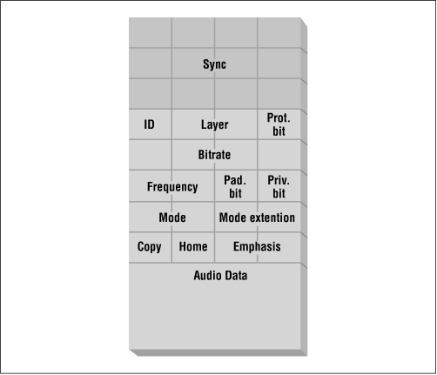
Figure 2-1: The MP3 frame header represented visually [1,2]

Another model of the structure of an audio frame is shown below in Figure 2-2.

Header (32)
CRC (0, 16)
Side Information (136, 256)
Main Data: not necessarily linked to this frame
Ancillary Data

Figure 2-2: Frame format for Layer-3 [2]
In this second model, the number of bits for each section is shown in parenthesis. The CRC and the ancillary data are optional. In particular, the ancillary data section is user defined, and might be used to transmit information about the song such as the artist or the title (usually as an ID3 tag). The side information is 136 bits in single channel mode and 256 bits in dual channel mode. The usage of the side information and the CRC are explained below as well as other features of Layer-3.

Bit Reservoir

MP3 processes the audio data in frames of 1152 sound samples. The use of a variable bit rate means that the coded data does not fit into a fixed length frame. “The encoder can [therefore] donate bits to a reservoir when it needs less than the average number of bits to code a frame. Later, when the encoder needs more than the average number of bits to code a frame, it can borrow bits from the reservoir”[2]. The “borrowing” just means that the system notes that there is more space left over from a previous frame where a future frame may write data. These borrowed bits can only come from past frames. As a result of this borrowing, the start of a frame does not necessarily follow its header so “the Layer-3 bit-stream includes a 9-bit pointer, “main_data_begin”, with each frame’s side information that points to the location of the starting byte of the audio data for that frame”[2]. The side information section contains other information necessary for decoding the main data. Error: Reference source not found shows the use of the bit reservoir to obtain a near constant frame size despite the variable bit rate.
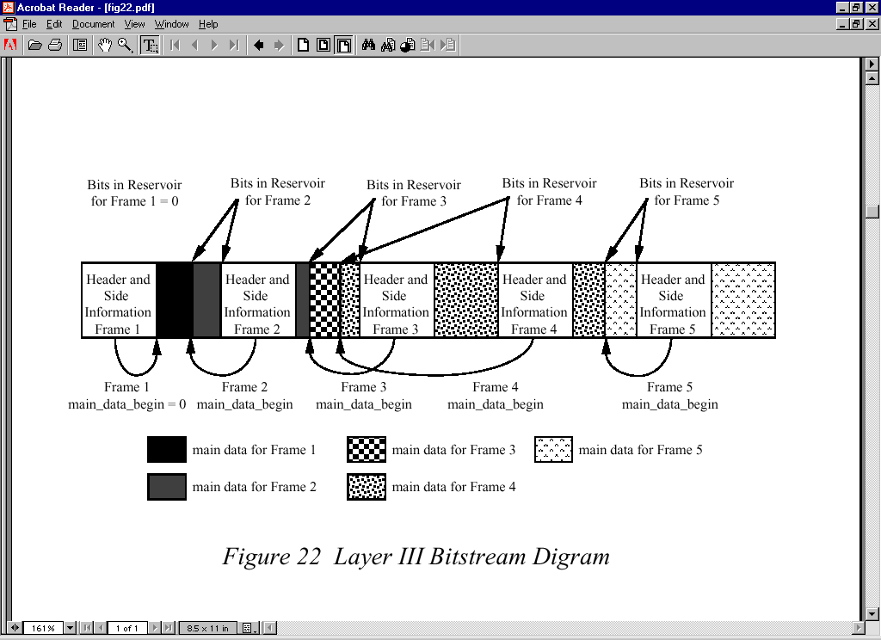
Figure 2-3: Layer 3 bit-stream diagram[2]
“Although the main_data_begin limits the maximum variation of the audio data to 2⁹ bytes (header and side information are not counted because for a given mode they are of fixed length and occur at regular intervals in the bit stream), the actual maximum allowed variation will often be much less. For practical considerations, the standard stipulates that this variation cannot exceed what would be possible for an encoder with a code buffer limited to 7,680 bits. Because compression to 320 kbits/sec with an audio sampling rate of 48 kHz requires an average number of code bits per frame of 1152 (samples/frame) * 320,000 (bits/sec) / 48,000 (samples/sec) = 7680 bits/frame “absolutely no variation is allowed for this coding mode”[2].

Audio Channel Modes

“The compressed bit-stream can support one or two audio channels in one of 4 possible modes:

- A monophonic mode for a single audio channel,
- A dual-monophonic mode for two independent audio channels (this is functionally identical to the stereo mode [and could be used to encoded different language versions of the audio]),
- A stereo mode for stereo channels with a sharing of bits between the channels, but no joint-stereo coding, and
- A joint-stereo mode that either takes advantage of the correlations between the stereo channels or the irrelevancy of the phase difference between channels, or both”[2]. By taking these correlations into account, one can achieve more efficient combined coding of the left and right channels of a stereophonic audio signal[3].

Sampling frequency

MP3 works at different sampling frequencies, which are dependent on the version of MP3 in use and determine quality of sound on playback, and affects the amount of data stored. “MPEG-1 defines audio compression at 32 kHz, 44.1 kHz and 48 kHz. MPEG-2 extends [MPEG-1 by adding half rates of the former sampling rates]… i.e. 16 kHz, 22.05 and 24 kHz”[3].

Bit-rate

MPEG Audio Layer-3 supports both fixed and variable bit rates. There are standard rates in the range 8 kbps to 320 kbps as well as an option for “a “free” bit rate mode to support fixed bit rates other than the predefined” [2] ones. Allocating different bit rates for any two frames within the bit-stream will result in a variable bit rate (VBR), while a constant bit rate (CBR), is specified by having the same bit rate for each frame in the stream. “Layer-3 decoders must support switching of bit rates from audio frame to audio frame”[3].

The difference between CBR and VBR are a little subtler than just having different bit rates for frames in the stream. CBR gives the system greater control over the size of each frame, sometimes to the detriment of sound quality. The encoder attempts to keep each frame a fixed size. “If an encoder does not find a way to encode a block of music data with the required fidelity within the limits of the available bit-rate, it “runs out of bits”. This may lead to the deletion of some frequency lines, typically affecting the high-frequency content”[3].

VBR encoding is a method that ensures high audio quality by allocating an appropriate (minimum) number of bits per second, depending on the complexity of the audio. A silence would be allocated a lower bit-rate while a complex portion of the sound would be allocated a higher rate with less compression and higher sound fidelity. As a result, the average bit-rate of the VBR stream may be lower than that of the constant bit rate. When using VBR, one must specify a quality factor that somehow relates (implementation dependent) to the range of bit-rates used during encoding.

As a rule of thumb, many writers suggest one that should use VBR encoding when consistent audio quality is the top priority and CBR if there is there are storage limitations and VBR produces too large a file. If one requires predictable behaviour (e.g. in a real-time environment), or there is limited bandwidth on the medium through which the data is to stream, then CBR should be chosen.

Cyclic Redundancy Check (CRC)

Audio frames may have an optional 16-bit CRC checksum. If used, the checksum comes after the frame header but before the audio data. Calculating the CRC for the received audio data and comparing it with the received CRC, may identify errors in the received bit stream. If a frame is corrupted, the normal procedure is either to repeat the previous frame, or mute the corrupted frame [ISO/ IEC 11172-3, 1993]. Only bits 16 to 31 in the header and the side information need to be used to generate the CRC word. This is because if there is an error in any of these values the whole frame could be misinterpreted, whereas an error in the audio data might only manifest itself as an audible glitch.

Others

The other parts of the frame header are informative. They provide extra information about the stream but are not very important to the decoding process (though they are needed, along with the others, to allow the decoder to identify the start of a frame). For more details on the structure of MP3 header frames, side information and CRC calculation, including the actual lookup tables necessary to derive certain details from the bit settings, go to http://www.mp3-tech.org/programmer/frame_header.html or http://www.iso.ch or see the Appendix.

MP3 Encoding Algorithm

“MPEG/audio is a generic audio compression standard. Unlike vocal-tract-model coders specially tuned for speech signals, the MPEG/audio coder gets its compression without making assumptions about the nature of the audio source [2]”. Figure 2-4 shows the block diagram of a typical MP3 encoder.

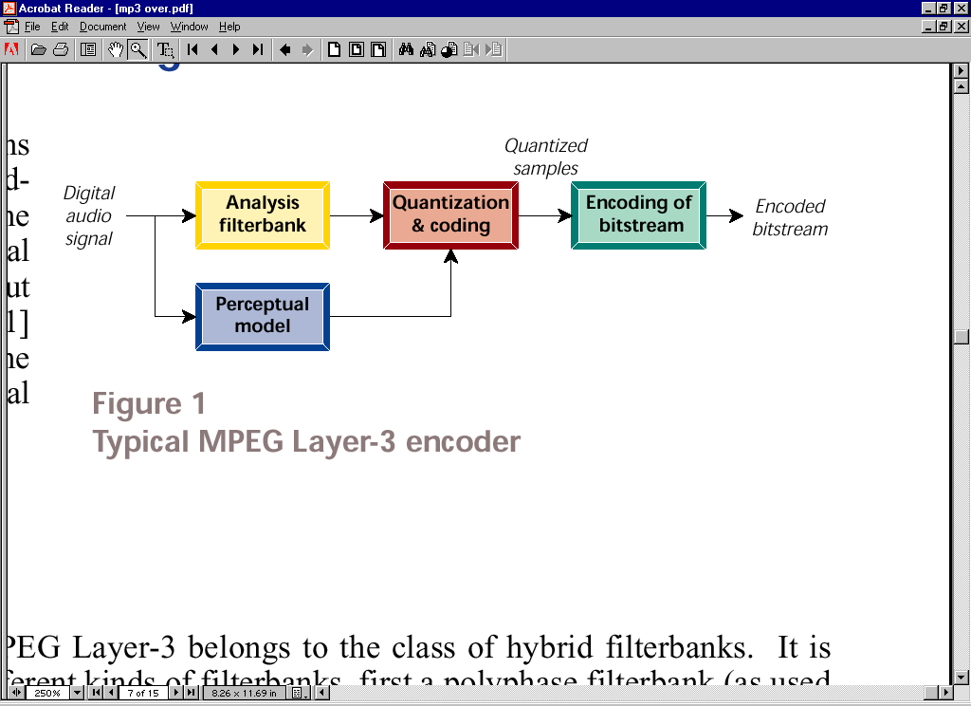

Figure 2-4: Typical MP3 Encoder [3]
As the diagram shows, the input audio stream enters the system at two blocks simultaneously. One of these blocks is an analysis filter-bank. The other is called the perceptual model (or psycho-acoustic model). The minimum equipment needed to do MP3 encoding is an Intel® Pentium® 133 MHz processor (without MMX support) and 32 MB of Random Access Memory (RAM)[7]. The sections below describe the basic function of each of the blocks.

Filter bank

MP3 uses a hybrid filter-bank built by cascading a poly-phase filter-bank and a Modified Discrete Cosine Transform (MDCT) filter-bank. The poly-phase filter-bank makes Layer-3 more similar to Layer-1 and Layer-2. Layer-3 needs to be like the other layers because the standard requires new layers to be able to decode data produced by previous layer versions. The hybrid filter-bank divides the input into a number of finer frequency sub-bands. This increases the potential for redundancy removal, leading to greater compression levels. “As a further positive result of the higher frequency resolution, the error signal can be better controlled, allowing finer tracking of the masking threshold”[3].

Perceptual model

“The perceptual model mainly determines the quality of a given encoder implementation…. The perceptual model either uses a separate filter-bank … or combines the calculation of energy values (for the masking calculations) and the main filterbank. The output of the perceptual model consists of values for the masking threshold or the allowed noise for each coder partition. In Layer-3, these coder partitions are roughly equivalent to the critical bands of human hearing. If the quantisation noise can be kept below the masking threshold for each coder partition, then the compression result should be indistinguishable from the original signal”[3].

Quantisation and Coding

This block uses the signal-to-mask ratios to decide how to distribute the total number of code bits available in such a way as to limit the number of possible amplitudes for each sub-band signal while minimising the audibility of the quantisation noise. “Quantisation is done via a power-law quantiser…. Larger values are automatically coded with less accuracy, and some noise shaping is already built into the quantisation process. The quantised values are coded by Huffman coding. To adapt the coding process to different local statistics of the music signals, the optimum Huffman table is selected from a number of choices”[2]. The Huffman tables (one for each sub-band) are another major data structure in MPEG-1 Audio Layer-III. They allow the data to be compressed but without degrading the quality.

Bit-stream Encoding

The bit-stream encoder is the last block in the process. It “takes the representation of the quantised subband samples and formats this data and side information into a coded bitstream. Ancillary data not necessarily related to the audio stream can be inserted within the coded bitstream”[2]. The header to the audio frame is attached here, as well as the CRC, if used.

On completion of all these stages, it is not unusual to achieve the following compression ratios and sound qualities:

sound quality | bandwidth | mode | bitrate | reduction ratio
telephone sound | 2.5 kHz | mono | 8 kbps * | 96:1
better than short-wave | 4.5 kHz | mono | 16 kbps | 48:1
better than AM radio | 7.5 kHz | mono | 32 kbps | 24:1
similar to FM radio | 11 kHz | stereo | 56...64 kbps | 26...24:1
near-CD | 15 kHz | stereo | 96 kbps | 16:1
CD | >15 kHz | stereo | 112..128kbps | 14..12:1
*Fraunhofer uses a non-ISO extension of MPEG Layer-3 for enhanced performance ("MPEG 2.5")
Table 2.1 Typical performance data for MPEG Layer-3[1]
An audio CD can store a maximum of 74 minutes of sound, requiring 650 MB of storage space. MP3 can, according to Fraunhofer, produce the same quality of sound at about one twelfth the space required for a CD, about 750 KB per minute of sound.

Factors determining encoder quality

“To date, large-scale and well-controlled listening tests are still the only method available for comparing the performance of different coding algorithms and different encoders…. These tests aim to stress the encoders under worst-case conditions… and then evaluate the performance of the encoders under test” [3].

As stated above, the quality of the perceptual model is a major determining factor for the perceived encoder quality. Implementing a very simple or no perceptual model can result in a fast encoder, but which performed poorly in some listening tests. There is obviously a trade-off between speed of encoding and sound quality.

“Especially at low bit-rates and low sampling frequencies, there is a mismatch between time resolution of the coder and the time structure of some signals. This effect is most noticeable on speech signals and when listening via headphones. As a single voice tends to sound like it has been recorded twice and then overlaid, this effect is sometimes called “double-speak” [3]. If sound quality is important then the encoder should support VBR and the audio input into the encoder should be sampled at a suitably high frequency.

MP3 Decoding Algorithm

A decoder is considered a valid MP3 decoder if the maximum deviation of the decoded signal is within a certain limit from a reference decoder which uses double precision arithmetic accuracy. “This allows us to build decoders running both on floating-point and fixed-point architectures. Depending on the skills of the implementers, fully-compliant high-accuracy Layer-3 decoders can be constructed with down to 20-bit arithmetic word length, without using double-precision calculations”[3]. In general terms, “the decoder deciphers [the encoded] bit stream, restores the quantised sub band values, and reconstructs the audio signal from the sub band values”[2]. Figure 2-5 shows the decoding process. The minimum equipment needed for these processes is a system with processing power equal to an Intel® Pentium® 75 MHz system with 16 MB of Random Access Memory (RAM)[3].
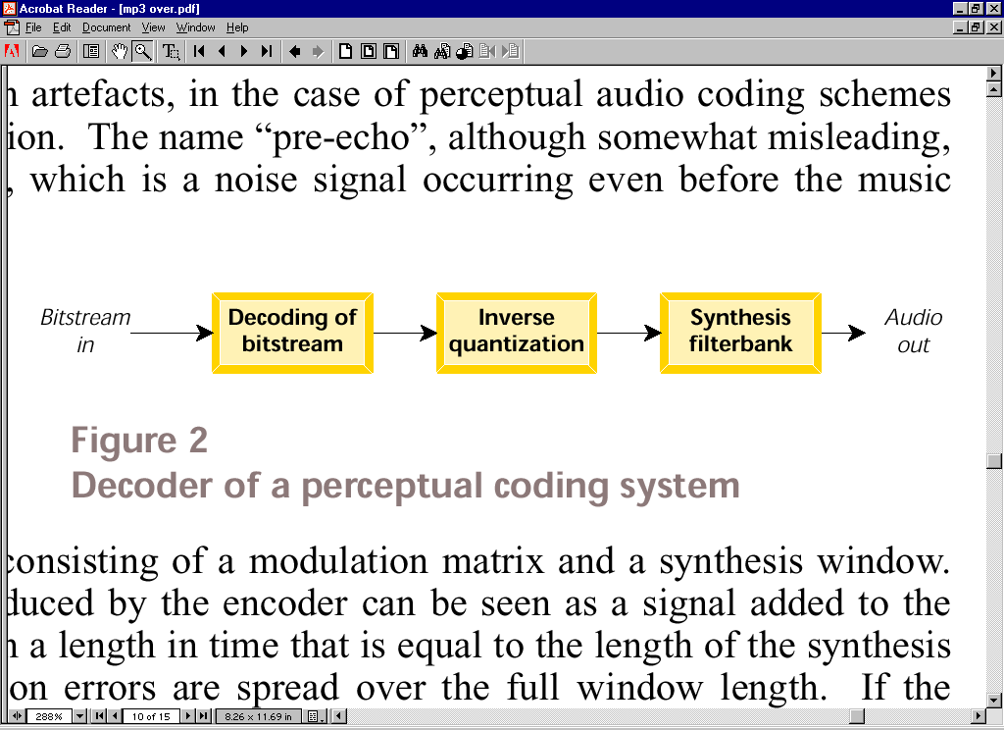
Figure 2-5: Basic functionality of MP3 Decoder [3]

Decoding of bit-stream

First, the incoming bit stream undergoes synchronisation. Here the contents of the bit-stream are identified and passed to succeeding blocks of the decoder. The process is also called bit-stream unpacking in literature [2]. This is done by finding the header frame and removing pertinent information. If CRC checking is enabled the CRC is extracted and used for error detection. If an error is detected, the frame is discarded and the system searches for a new header. The input bit-stream is also decoded (and decompressed) here using a Huffman table, and expanded to its raw form before the loss-less compression. If included, the ancillary data is also extracted.

Inverse Quantisation

The decoded bit-stream is decompressed even further by multiplying each sub-band by the inverse of the value by which they were scaled during the quantisation phase of the encoder. On completion, the frequency samples are reconstructed with some error related to the quantisation process.

Synthesis Filter-bank

The synthesis filter-bank performs the inverse operation of the analysis filter-bank, thereby converting the sound data from the frequency domain, to the time domain, using the Inverse Modified Discrete Cosine Transform (IMDCT) followed by the synthesis of the poly-phase filter-bank. The sum effect is the reconstruction of the audio signal. The output of this stage is a digital Pulse Code Modulation (PCM) signal.

Generating the Output Sound

Once the sound has been decoded, it is ready for playback. During playback, the digital sound must first be converted to an analogue form, then outputted via speakers. Two types of speakers are generally used to playback MP3 sound, namely passive and amplified speakers. Passive speakers are typically used in combination with an amplifier. They produce minimal volume without amplification. Amplified speakers have their own amplifier, usually integrated into one or more of the speakers. The MP3 standard requires a decoder to be able to support stereo sound. Stereo is defined as “designating sound transmission from two sources through two channels”[3]. This means that during playback there should be at least two speakers, one for each encoded channel. Figure 2-6 shows the operations occurring during playback.

Digital to Analogue Conversion
Amplifier

(Optional)
Analogue Signal
Left Channel
Right Channel
Digital Audio signal from decoder

Figure 2-6: Playback of the audio stream

Digital to Analogue Conversion

This process may be undertaken by the computer’s sound card or by custom hardware. If custom hardware is used a digital to analogue converter (DAC) chip is utilised. A quick check for Audio DAC chips at a local electronics supplier (Farnell) revealed two dual audio DACs (DAC chips with support for two input and two output channels on a single chip). Both devices are manufactured by Analog Devices®, each having dual serial input, dual serial output, and a single +5 V Supply. Both operate at 8 x over-sampling frequency and are packaged as 16-pin plastic DIP or SOIC.

“Digital to analogue over-sampling is a process whereby the player reads two samples, and additional values are “interpolated” between the two. In an 8x over-sampling playback system, 7 additional values are inserted between the actual single samples”[3]. Over-sampling is used to remove artefacts. Another benefit of over-sampling is the reduction of quantisation noise. The interpolation might use a special algorithm, such as Smith-Gossett [4] algorithm used in some Digital Signal Processors, or be just simple linear interpolation.

A dual audio DAC is preferred, over two single audio DACs, as the cost of two single DACs is usually greater than the cost of a single dual audio DAC. Another reason for the choice was the fact that the dual DAC is a complete system on a chip. Systems on a single integrated circuit (IC) tend to consume less power than systems on multiple chips, as there are fewer line drivers. Systems on a chip also tend to be more reliable as there are fewer solder points that could crack during handling and general use.

The major difference between the two dual DACs, sold at Farnell, is the number of bits in a sample. The AD1866 is a 16-bit DAC while the AD1868 is an 18-bit DAC. As only 16-bit resolution is required to meet the minimum criteria for CD quality sound, the AD1866 was selected. “A versatile digital interface allows the AD1866 to be directly connected to all digital filter chips. Fast CMOS logic elements allow for an input clock rate of up to 16 MHz. This allows for operation at 2x, 4x, 8x, or 16x the sampling frequency [of 44.1 kHz] for each channel”[3]. The maximum clock rate of the AD1866 is specified to be at least 13.5 MHz.

There are two points where the DAC might be connected to the FPGA board, the 50-pin Aux I/O header and one of the two PMC interfaces. The 50-pin unassigned I/O header is the more suitable as it is designed for custom interfaces unlike the PMC points which are really for data conforming to the PCI standard. Figure 2-7 shows how the DAC might be connected.

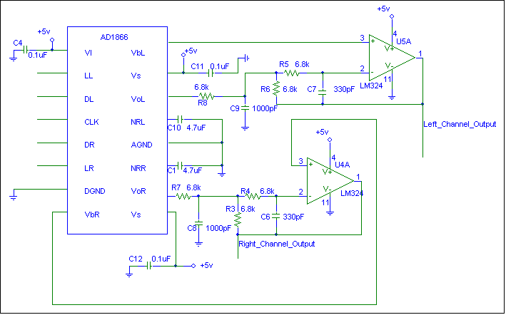
Figure 2-7: Interfacing the AD1866 to the 50-pin AUX
The circuit is essentially the DAC channel outputs connected to RC low-pass (anti-alias) filters to filter out the frequencies above 20 kHz. LL, DL, CLK, DR, LR, DGND and all +5V and ground supplies are from the FPGA. The channel outputs could either be connected to a single 3-pole jack socket, separately to two 2-pole jack sockets, or to the speakers directly.

Table 2.2 describes each of the AD1866’s 16-pins.

Pin# | Pin Name | Description
1 | V_{L} | Digital Supply (+5V)
2 | LL | Left Channel Latch Enable Pin
3 | DL | Left Channel Data Input Pin
4 | CLK | Clock Input Pin
5 | DR | Right Channel Data Input Pin
6 | LR | Right Channel Latch Enable Pin
7 | DGND | Digital Common Pin
8 | V_{B}R | Right Channel Bias Pin
9 | V_{S} | Analogue Supply (+5 V)
10 | V_{O}R | Right Channel Output Pin
11 | NRR | Right Channel Noise Reduction Pin
12 | AGND | Analogue Common Pin
13 | NRL | Left Channel Noise Reduction Pin
14 | V_{O}L | Left Channel Output Pin
15 | V_{S} | Analogue Supply (+5 V)
16 | V_{B}L | Left Channel Bias Pin
Table 2.2: Pin Descriptions for AD1866Error: Reference source not found[11]
The frequency of the input clock is given by the equation:

Frequency = sampling frequency * number of bits per sample * over-sampling rate

The sampling frequency is the value in the MP3 header.

Amplifier

The amplifier converts the analogue signal from the DAC to the chosen user sound “loudness” value, which must be between the positive and negative supply voltage rails of the speakers. Two 5-10 Watt (W) Root Mean Squared (RMS) passive speakers will produce a discrete sound without amplification. Two 20-50 W RMS active speakers will produce a very loud sound. As stated previously the amplifier may be part of the speaker unit(s) or may be a stand-alone unit.

Conclusion and Summary

In this section, an overview of the basic functionality of a MP3 encoder and a MP3 decoder was presented. The features that make Layer-3 achieve high levels of compression while maintaining high sound quality were also introduced. The two main data structures for successful encoding and decoding, namely the audio frame structure and the Huffman tables, were also identified. Frames allow skipping, fast-forwarding and reversing of the audio stream providing similar functions available to CD players. Finally, the method to produce sound during playback was described. The ISO/ IEC 11172-3:1993 standard allows implementations to be either floating or fixed point with a minimum word length of 20-bits for the arithmetic operations. This latter point is important as the hardware implementation language, Handel-C does not provide support for floating point numbers, and a small word length will result in a design that uses less chip area than one with a longer word.

MP3 Encoder selection:

The following section highlights differences between various implementations of MP3. Comparisons are made using certain selection criteria discussed below. An educated decision is then made regarding the choice of encoder, based on the results of the comparisons.

The Criteria & Justification:

Whenever there is a choice to be made, the goal is usually to select the “BEST” candidate for the job. The factors that determine what is “BEST” are essentially subjective. The following criteria were drawn for selecting the codec that will be “BEST” for our application. These are:

- Variable bit rate encoding
- Fixed point
- Open source
- Sound quality
- Speed of execution
- Result of Independent comparisons
- Frequency of public domain usage.

Bit-Rate encoding:

Bit rate encoding has a direct effect on quality of the compressed sound and the size of compressed sound file. There are three different bit-rate encoding techniques used by MP3 encoders. They are Constant Bit Rate (CBR), Average Bit Rate (ABR) and Variable Bit Rate (VBR). These have direct effect on compression and sound quality [27,29].

CBR as the name suggests is an encoding technique that allocates a constant bit-rate and encodes the stream at that rate. This method undermines the sound quality such that, if the bit-rate is low, and music is complex, compression at that rate distorts the music. If the audio is simple, for example, a silence, CBR may introduce a “hiss” sound.

ABR is a technique that allows the user to choose an average bit rate, and the encoder adding bits if necessary.

VBR, on the other hand uses a method that makes intelligent decisions during encoding by allocating as much bandwidth as required. The draw back is that the size of the compressed sound file is unpredictable. Where high sound quality is needed, this method is the best.

Fixed-point:

The system is to be implemented on an FPGA, and as such, a fixed-point implementation is preferred. Libraries are available for implementing floating point operations in Handel-C, however these add a certain degree of complexity.

Open Source

Naturally, it is necessary for us to use an open-source implementation of the MP3 algorithm, as we require all the source code for analysis in both design methodologies. Furthermore, we have a limited budget, and would prefer not to purchase licensed software. Open source also allows us to concentrate more on the design process, and not on the development of the initial software application; the design process is the main area of investigation in the project.

Sound quality:

Since MP3 is a lossy compression technique, the quality of the compressed sound is of high importance. The technique is based on removing the superfluous sounds to reduce the size of the file, which might cause harmonic distortions. The quality of compressed sound and the ratio of compression are directly linked. A trade-off between the two is always exists.

Apart from the harmonic distortion, there are other sound deficiencies or “artefacts”, which are dependent on the parameters, and sophistication of the encoder [3]. The artefacts to look for are pre-echo, over-ring and bandwidth loss.

There are three different methods for determining compressed audio quality in the literature [3]. These are listening tests (subjective), objective measurement techniques, and perceptual measurement techniques. The application of any of these techniques by DEEP-3 however, is out of the scope of the project. Therefore, it has been decided to use independent comparison results for quality determination.

Candidate Encoders:

Four encoders were considered for usage. They are LAME, BladeEnc, Fraunhoffer (FhG) and Xing.

Table 3.2 summaries the encoders and compare their features against some of the criteria of fitness for our purpose.

Encoder Name | Bit-Rate encoding | Fixed Point | Multiple input | Open source
LAME | CBR, ABR, VBR | No | Yes | Yes
BladeEnc | CBR, | No |  | Yes
Xing | CBR, VBR | N/A |  | No
FhG | CBR, VBR | N/A |  | No
Table 3.2: Encoder V Criteria
As can be seen, only two of the encoders are open-source, and none are fixed point. BladeEnc does not support VBR encoding. LAME has more of the desirable features than the other encoders considered.

Independent Test Results, Methods and Test data:

Four comprehensive comparison tests carried out by independent bodies [16,21, 22, 26] and are considered here. Three of the tests are comparing MP3 encoders directly while the fourth one is comparing MP3 against CD and a different technology, namely OGG. Table 3.2 is a summary of what the tests found. From this data, it becomes apparent that LAME emerged on top in most of the listening tests.

Test subject | Bit-Rate Range | Test method | Test data | Verdict | Tester
FhG, LAME, BladeEnc | 32-64 | Visual analysis using “sonogram” | Unknown | BladeEnc produce pre-echo  FhG has over-ring | [22]
FhG, LAME, BladeEnc | 128 kbps (VBR) | Visual analysis using “sonogram” | Unknown | BladeEnc produce pre-echo  FhG has over-ring | [22]
FhG, LAME, BladeEnc | 196-256- 320 | Visual analysis using “sonogram” | Unknown | LAME bits the peak performance | [22]
FhG, Xing, LAME 3.61, BladeEnc. | 128, 196, 256 | Band-with analysis | Wave file | For hight bit rate 192-256 Fraunhofer, LAME, Blade, and Xing (in order of preference) . For detail see appendix 3 | [21]
FhG, Xing, LAME3.61, BladeEnc. | 128, 196, 256 | Object measurement | Dirty Blue |  | [21]
FhG, Xing, LAME 3.61, BladeEnc. | 128, 196, 256 | Listening | See appendix 2 |  | [21]
LAME 3.89b, FhG | 128 kbps | N/A | Unknown | -LAME top or near top  -Xing not suitable candidate | [26]
LAME, OGG, CD | 128 | Object measurement | -Crush On You,  -Mano a Mano  -What A Feeling  -Ist Deine Liebe Echt  -Autumn Tactics | OGG is leader | [16]
LAME, OGG, CD | 160 | Object measurement |  | OGG is leader | [16
LAME, OGG, CD | 192 | Object measurement |  | LAME better on a whole | [16]
LAME, OGG, CD | 256 | Object measurement |  | LAME better with high frequency  OGG good with middle | [16]
LAME, OGG, CD | 320-350 | Object measurement |  | Both encoders do excellent | [16]
Table 3.3 Test result summary

Public domain usage:

Table 3.4 shows the frequency of usage of the encoders in third-party products.

 | Name | Encoder included | Platform supported
1 | AltoMP3 Maker | LAME Encoder | Win 95/98/2000/NT/ME
2 | N-Koder | LAME Encoder | Win 95/98/NT/2000
3 | Easy CD Ripper | LAME Encoder | Win 98/NT/ME/2000/XP
4 | YAMP | LAME Encoder | Win 95/98/2000/NT
5 | Adv. Encode Decode Tools | LAME Encoder | Win 95/98/NT/2000/ME
6 | MPAction Tools | LAME Encoder | Win 95/98/NT/2000
7 | Audio Companion | LAME Encoder | Win 95/98/2000/NT
8 | Rob Fantastic MP3 Encoder | LAME Encoder | Win 95/98/2000/NT
9 | Waver | LAME Encoder | Win 95/98/2000/NT/ME
10 | Easy CD-DA Extractor | LAME Encoder | Win 95/98/2000/N/XP
11 | Mighty DAC | LAME Encoder | Win 98/ME/2000/N/XP
12 | CD Stripper | LAME Encoder | Win 95/98 NT/2000/ME
13 | JukeIt Up | LAME Encoder | Win 95/98 2000/ME
15 | CDex | LAME Encoder | Win 95/98/NT
16 | dbPoweramp | LAME Encoder | Win 95/98/NT4/ME/2000
17 | FreeRip MP3 | LAME Encoder | Win 95/98/NT4/ME/2000
18 | CD to MP3 Maker | LAME Encoder | Win 95/98/NT/ME/2000
19 | Xing Encoder | Xing Encoder | Win 95/98/NT
20 | Audio Catalyst | Xing Encoder | Win 95/98/NT
21 | Froebis MP3 Studio | Xing Encoder | Win 95/98/NT
22 | MusicBoss Grabber | Xing Encoder | Win 95/98
23 | MP3Enc | Fraunhoffer Encoder | Win 95/NT
24 | Rosoft Audio Tools | Fraunhoffer Encoder | Win 95/98/NT/2000
25 | AudioActive Production Studio | Fraunhoffer Encoder | Win 95/98/NT
26 | MusicMatch | Fraunhoffer Encoder | Win 95/98/ME/NT/2000
27 | Siren Jukebox | Fraunhoffer Encoder | Win 98/2000/ME
28 | MP3HomeStudio | Fraunhoffer Encoder | Win 95/98/ME/2000
29 | Audio Companion | BladeEnc Encoder | Win 95/98/2000/NT
30 | Rob Fantastic MP3 Encoder | BladeEnc Encoder | Win 95/98/2000/NT
31 | Waver | BladeEnc Encoder | Win 95/98/2000/NT/ME
32 | CD Copy | BladeEnc Encoder | Win 95/98 NT/2000
33 | MP3 Strip It! | BladeEnc Encoder | Win 32/95/98 2000/NT4
34 | RightClick | BladeEnc Encoder | Win 95/98/NT
35 | Audio MP3 Maker | BladeEnc Encoder | Win 95/98/NT/ME/2000
36 | Blaze Media Pro | Other | Win 95/98/NT/2000/ME
37 | AudioWriter | Other | Win 95/98/NT/2000
38 | AudioConvert | Other | Win 95/98/2000/NT/ME
39 | TsunamiPro | Other | Win 95/98/NT
40 | HyCD | Other | Win 95/98 2000/NT/ME
41 | MP3 to Exe | Other | Win 95/98/NT
42 | PC Music | Other | Win 95/98
43 | SoundLimit | Other | Win 95/98/NT
Table 3.4 Public domain usage
As the table clearly shows, LAME is the most commonly used encoder for the Windows® environment. Frequency of usage does not necessarily reflect quality, (for example, the VHS/BetaMax scenario of the 1980s). However, from Table 3.3, LAME was shown to be capable of producing very high quality audio and so frequency of usage can be assumed to be related to product quality.

Conclusion:

Having compared several MP3 encoders, it was found that LAME has more desirable characteristics than the other encoders examined. It is open-source, widely used throughout the public domain, and as such has been subjected to rigorous peer appraisal. It has a broad range of features, and a multitude of GUIs. Although LAME does not have a fixed-point implementation, its success in all the other categories, has led to it being chosen as a base for our project.

Cryptography

This section will contain a brief overview of encryption techniques. After a comparison of the surveyed techniques, an encryption algorithm will be chosen. This research has already been conducted, although not formalised, and Pretty Good Privacy (PGP) was chosen for implementation. This will allow us to use public key RSA, along with some form of pass-phrase.

Walkthrough

Upon initial use of the system, the user will be prompted for a pass-phrase to secure his/her private key. At this point, the system will generate a public/private key pair. The private key will be “locked” using the memorable pass-phrase, and the public key can be broadcast or placed somewhere it may be accessed by other users.

Anyone will be able to obtain and use a given public key to encrypt an MP3. The MP3 can then be transmitted or stored securely, with very little danger of the information being read by an unwanted third-party. In our project, we have decided that the encrypted MP3 should be stored on the user’s computer (legal issues about MP3 streaming). When the user comes to play MP3s, s/he will be prompted once for the pass-phrase. This pass-phrase will “unlock” the PGP private key, which can then be used to decrypt, decode and play the MP3.

Summary

A summary of reasons for choosing PGP over other alternatives is presented below:

- It is an open standard, which has been tried and tested over several years.
- It is so far conjectured to be cryptographically secure given a sufficient key size.
- It includes an implementation of a public key encryption algorithm (RSA). This means data can be encrypted by anyone who has access to the user’s public key, but only decrypted by the user with the relevant private key.
- It incorporates a facility for a pass-phrase to promote ease of use. More specifically, it is easier to remember a meaningful, user-defined pass-phrase than to remember the random string of numbers that constitute the private key.

User Interface Analysis and Design

The user interface is the central communication between the user and the system, this section describes the role of user interface and its functionality within the system. It also discusses the concept of user interface design and requirements for the DEEP-3 system.

Before start designing the user interface for the system, it is important understand what is meant by the term “User Interface”.

What is a “User Interface?”
The term “User Interface” refers to the methods and devices that are used to accommodate interaction between machines and the human beings who use them (users). User interfaces can take on many forms, but always accomplish two fundamental tasks: communicating information from the machine to the user, and communicating information from the user to the machine.
The term user interface generally refers to those of computers, but this is only one example. Consider voice mail and other automated systems such as the telephone. These communicate information to the user in the form of audio messages, and the user communicates information back by pressing touch-tone buttons. A further removed example would be the user interface of automobiles. The automobile communicates information to the user through gauges and dials, and the user communicates information to the automobile through the steering wheel, foot pedals, and other controls. Any machine that requires interaction with human beings will have some sort of user interface.

Concept of User Interface Design

Intuitiveness
It is generally perceived that the most fundamental quality of any good user interface should be that it is intuitive. The problem is that “intuitive” means different things to different people. To some an intuitive user interface is one that users can figure out for themselves. There are some instances where this is helpful, but generally the didactic elements geared for the first-time user will hamper the effectiveness of intermediate or advanced users.
A much better definition of an intuitive user interface is one that is easy to learn. This does not mean that no instruction is required, but that it is minimal and that users can “pick it up” quickly and easily. First-time users might not intuit how to operate a scroll bar, but once it is explained they generally find it to be an intuitive idiom.
Icons, when clearly unambiguous, can help to make a user interface intuitive, but it is still very important to never overlook the usefulness of good old-fashioned text labels. Icons depicting portrait or landscape orientation, for example, are clearly unambiguous and perhaps more intuitive than the labels themselves, but without the label of “orientation,” they could still make no sense at all.

Labels should be concise, cogent, and unambiguous. A good practice is to make labels conform to the terminology of the business that the application supports. This is a good way to pack a lot of meaning into a very few words, this is particularly important in application such as this DEEP-3 System.
Designing intuitive user interfaces is far more an art than a science. It draws more upon skills of psychology and cognitive reasoning than computer engineering or even graphic design. The process of Usability Testing (more on this in forthcoming section), however, can assess the intuitiveness of a user interface in an objective manner. Designing an intuitive user interface is like playing a good game of tennis. Instructors can tell you how to do it, but it can only be achieved through hard work and practice with a lot of wins and losses on the way.

Consistency
Consistency between applications is always good, but within an application it is essential. The standard GUI design elements go a long way to bring a level of consistency to every panel, but “look and feel” issues must be considered as well. The use of labels and icons must always be consistent. The same label or icon should always mean the same thing, and conversely the same thing should always be represented by the same label or icon.
User interface designers should always provide permanent objects as unchanging reference points around which the users can navigate. If they ever get lost or disoriented, they should be able to quickly find the permanent objects and from there get to where they need to be. On the Macintosh, the apple menu and applications menu are examples of permanent objects. No matter what application the user is in, those objects will appear on the screen.

Simplicity
A good gauge of simplicity is often the number of panels that must be displayed and the number of mouse clicks or keystrokes that are required to accomplish a particular task. All of these should be minimised. The fewer things users have to see and do in order to get their work done, the happier and more effective they will be.
A good example of this is the way in which the user sets the document type in Microsoft Word version 5.0 as compared to version 4.0. In version 4.0, the user clicks a button on the save dialog that presents another panel in which there is a selection of radio buttons indicating all the valid file types. In version 5.0, there is simply a popup list on the save dialog. This requires fewer panels to be displayed and fewer mouse clicks to be made, and yet accomplishes exactly the same task.

A pitfall that should be avoided is “featuritis” providing an over-abundance of features that do not add value to the user interface. New tools that are available to developers allow all kinds of things to be done that weren't possible before, but it is important not to add features just because it's possible to do so. The indiscriminate inclusion of features can confuse the users and lead to “window pollution.” Features should not be included on a user interface unless there is a compelling need for them and they add significant value to the application.

Prevention
A fundamental tenet of graphic user interfaces is that it is preferable to prevent users from performing an inappropriate task in the first place rather than allowing the task to be performed and presenting a message afterwards saying that it couldn't be done. This is accomplished by disabling, or “greying-out” certain elements under certain conditions.

Forgiveness
One of the advantages of graphic user interfaces is that with all the options plainly laid out for users, they are free to explore and discover things for themselves. But this requires that there always be a way out if they find themselves somewhere they realise they shouldn't be; special care is taken to make it particularly difficult to “shoot themselves in the foot.” A good tip to keep users from inadvertently causing damage is to avoid the use of the OK button and use the DEFAULT button, if possible, in critical situations. It is much better to have button labels that clearly indicate the action that will be taken.

Aesthetics
Finally, it is important that a user interface be aesthetically pleasing. It is possible for a user interface to be intuitive, easy to use, and efficient and still not be terribly nice to look at. While aesthetics do not directly impact the effectiveness of a user interface, users will be happier and therefore more productive if they are presented with an attractive user interface.

DEEP-3 User Interface Overview

The DEEP-3 user interface consists of two stages, the first stage is represented by a SIGN ON menu as shown below. The second stage is the DEEP-3 system menu (as shown in figure 3). All users of the DEEP-3 system must be registered, once an account has been opened, the user will be given a user name and password, which will enable he/she to gain access to the DEEP-3 system.
The user is required to type in the user-name and password every time he/she wishes to use the system; the information entered by the user is then verified with a database. If the information entered is correct, the user will be able to log on to the system, otherwise an error message will be displayed.

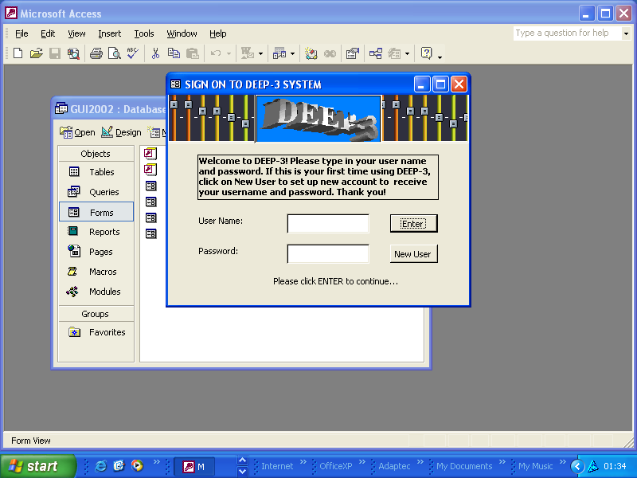
Figure 1. The Sign On Menu of the DEEP-3

One important design decision that need to be considered when designing the Sign On menu is whether to make a drop-down list style for the user-name. In doing this, the system allows the user to select his/her name from the drop-down list and then type in the password to enter the system. The problem with this style is that unauthorised user can just select any user-name from the list and guess the password to gain access to the system. Without the drop-down list, it will be much more difficult for unauthorised users to access the system as they would have to enter both user-name and password correctly.

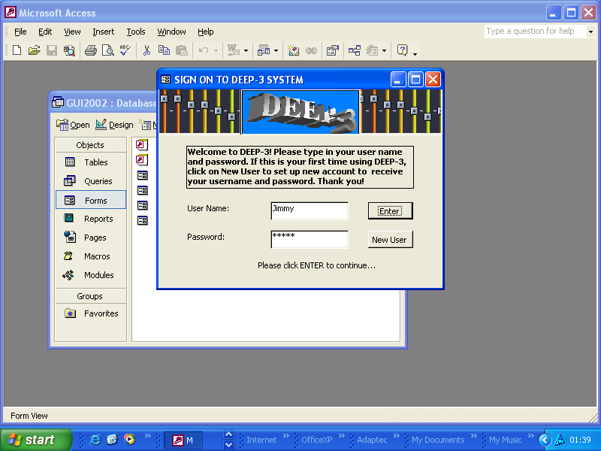
Figure 2. The Signing On Process
When valid user-name and password have been entered, the user will be able to access theDEEP-3 main menu. In this menu, the user can play the encrypted MP-3 files with all the standard features such as player options, audio mode selector, create list of files to be played or save files.

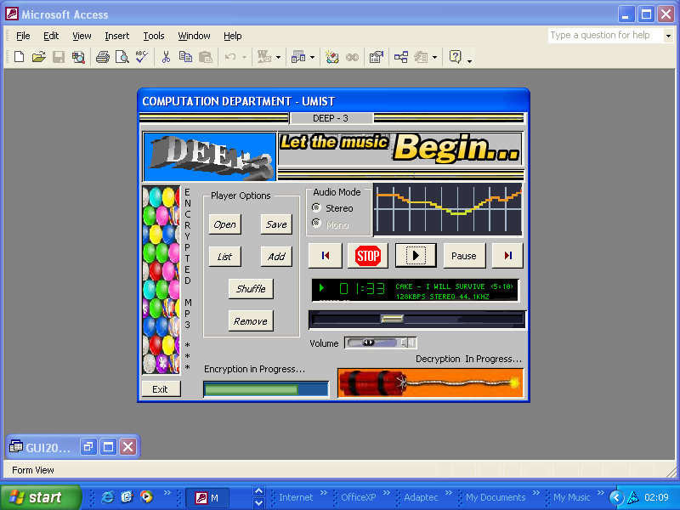
Figure 3. The DEEP-3 System Menu
Figure 5-8:The Signing On Process

When valid user-name and password have been entered, the user will be able to access theDEEP-3 main menu. In this menu, the user can play the encrypted MP-3 files with all the standard features such as player options, audio mode selector, create list of files to be played or save files.

Figure 5-9: The DEEP-3 System Menu

System Architecture

This chapter describes the DEEP-3 system architecture. It includes a detailed description of hardware and software components such as Handel-C, the FPGA chip and its associated board from Celoxica™.

The DEEP-3 system architecture is shown in figure 6.1. The system consists of five main units, a general-purpose processor, a storage device, local memory, sound input/output devices, and a re-configurable device (RC1000 board, which supports the XILINX® Virtex™ XCV1000 FPGA). These components were derived from the investigation in the previous sections.

DMA
Host CPU
(x86)
RC-1000 Board
(FPGA – Memory)
Storage Device
Memory (RAM)
Sound Card

Speakers
Line In
CD-ROM
Microphone
PCI Bus
IDE Bus

Figure 6-10 DEEP-3 System Architecture

Host CPU is a general-purpose instruction-set processor, which can perform a variety of tasks. The host CPU to be used with DEEP-3 is an x86 processor with a clock frequency of 1 GHz. The overview on MP3 suggested that the minimum processor required for encoding was an x86 processor at 133MHz so we are certain that the architecture can support MP3 encoding.

The main operating system (OS) to be used during development is Windows 2000®. Linux may be used or a UNIX emulator, for example CYGWIN, when porting GCC to our target processor. The host CPU, together with the OS, provide the necessary drivers for I/O.

During development the FPGA design tool suite (DK1) are executed on the host CPU. These tools allow us to describe the hardware functions during partitioning, or the processor model during ASIP design. DK1 can either simulate the system or configure the RC-1000 for execution of the application. The tools can also optimise the design so it uses an optimal portion of gates.

The XILINX® Virtex™ XCV1000 FPGA and RC1000 board act as co-processor to the host CPU, accelerating application execution by providing extra system resources.

The OS provides the framework for generating the user interface. It also allows us to store audio files, source files and other project related material, play sound when testing the applications behaviour during decoding and playback, as well as receive sound input during compression and encryption.

The host CPU that’s being used for this project is the x86 family AMD Athlon® processor.

Local Memory is also known as random access memory (RAM). This memory can be accessed directly by the system processor or by the FPGA.

Storage Device is used to store data such as program source code and audio files. This device is a hard disk because the data to be stored will be greater than the capacity of a floppy disk. The system processor reads and writes to this hard disk using the IDE-bus.

CD-ROM is a compact disk read only memory device used to read in data from standard compact disk. For this system, the CD-ROM is used to read audio files from audio CDs to the system. These audio files are the input of the MP3 encoding process.

Microphone is used as an input device to the system. Sound can be recorded to the system through this microphone. Having sound input from multiple sources is key to effective testing.

Sound Card is an expansion board that enables a computer to manipulate and output sounds. Sound cards enable the computer to output sound through speakers connected to the board, and to record sound input from a microphone. In the initial stages, we will use the sound card for sound output. Later in the project, we will implement an interface between the FPGA and the speakers so that we can play the audio directly.

RC-1000

Another piece of important hardware shown in the system architecture is the RC-1000 board. The RC-1000 board [31] is a standard PCI bus card equipped with a XILINX® Virtex ™ family BG560 part with up to 2 million system gates. It has 8Mb of SRAM directly connected to the FPGA in four 32-bit wide memory banks. The memory is also visible to the host CPU across the PCI bus as if it were normal memory. Each of the four banks may be granted to either the host SRAM on the board. It is then accessible to the FPGA directly and to the host CPU by DMA transfers either across the PCI bus or simply as a virtual address. The board as shown in Figure 6.3, is equipped with two industry standard PMC connectors for directly connecting other processors and I/O devices to the FPGA, a PCI-PCI bridge chip also connects these interfaces to the host PCI bus, thereby protecting the available bandwidth from the PMC to the FPGA from host PCI bus traffic. A 50-pin unassigned header is provided for either inter-board communication, allowing multiple RC1000s to be connected in parallel or for connecting custom interfaces. The support software provides Linux (Intel), Windows® 98, NT® 4.0+, and Windows 2000 drivers for the board together with application examples written in Handel-C. The board may also be programmed using the XILINX ® Alliance Series and Foundation Series software tools and other EDA tools.

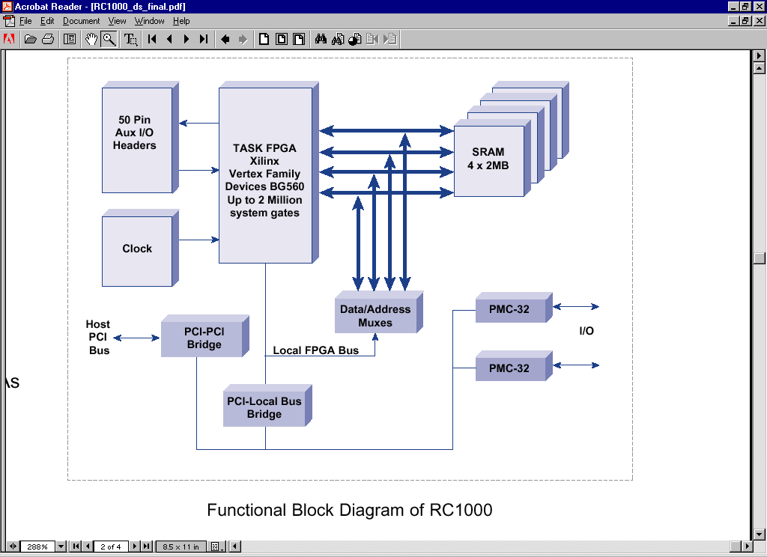Figure 6-11: Functional Block Diagram of RC1000[?]

Processor Core Design

Introduction

In the following section, we will outline the design of the hardware, specifically the detailed design of the ASIP. The initial aim will be to develop a working processor model running on the FPGA, capable of executing short sequences of hand-written assembly code. From here, we will attempt to re-target the C compiler, GCC to compile programs of a higher degree of complexity for our processor. Finally, we intend to tune the processor to the encryption and compression applications. This will be done in the form of customising the instruction set as described in Generating Instruction Sets and Micro-architectures from Applications [12].

Hardware Overview

Figure 7.1 shows the initial processor model.

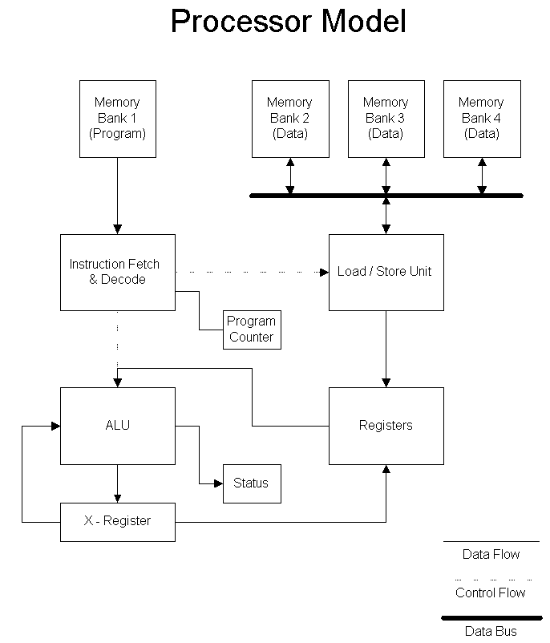
Figure 7-12: Initial Processor Model
We have decided to implement a generic RISC family core as these are well documented, and existing implementations of GCC can be converted to accommodate the customised instruction set. Initially, we will focus on what is known as coarse grain optimisation and customisation. In this sense, we use the word “optimisation” to mean a “tuning” of the processor to make it more specific to the target application. This may involve removing redundant instructions or processor features, or perhaps improving existing features. Rather than just concentrating on getting the fastest computation times out of the processor, we also aim to use FPGA resources more efficiently than a general-purpose processor implementation would. For example, if the compiler only references four registers in the generated byte-code, only four registers need to be implemented on the FPGA.

If time permits, it is hoped that once the coarse grain optimisations have been completed we will evolve the architecture to Very Long Instruction Word (VLIW). Using VLIW architecture will enable a higher degree of parallelism to be exploited on the FPGA, by executing certain instructions (that would otherwise be sequential) in parallel.

Why RISC?

A RISC processor model was chosen due to popular conjecture that approximately 80% of the code is executed using 20% of the instructions. Because instructions that are more complex take longer to execute, RISC processors have a significant performance advantage over CISC processors. RISC processors are more efficiently pipelined, and can therefore exploit a higher degree of parallelism than CISC.

By taking an initial instruction set and discovering the most commonly used instructions one can improve performance by customising/optimising these. Space considerations were also a factor in deciding upon a suitable instruction set. Although CISC architecture substantially reduces the overall program size, it is important to note that RISC significantly decreases the number of gates required on the FPGA.

Harvard Architecture

The core will implement a Harvard architecture, which uses separate data and program buses. This architecture is less common than Von Neumann architecture, due to the additional number of pins required when implementing the processor in real hardware. This is not a consideration in the FPGA implementation, as the number of pins is fixed. The perceived main advantage to implementing Harvard architecture is the performance gain achieved by separating the interests of data and processor instructions. This allows both data and instructions to be written and read simultaneously, with neither being restricted by a shared bus. We concede that Harvard is more difficult to implement than Von Neumann architecture, so as part of our risk management strategy we intend to prototype our system with Von Neumann. As we get more confident with the development environment, we will then migrate to Harvard.

Memory Banks

The FPGA has four memory banks, each of two megabytes. We believe that one bank should be sufficient to store the program itself. This allows us three banks for data: One for a heap, one for a stack and one for general application data.

Registers

The registers will initially be 32-bits wide, as this makes targeting of GCC slightly less complex. At a later stage, these may be decreased if it is believed that there is a performance advantage in doing this (either in time or space complexity). In the MP3 design section we found that MP3 can be implemented with a 20-bit word length and still produce high-quality audio. This is also considered here.

There will probably be at least 16 registers, most of which will be general purpose. There will also be a program counter, and an X-Register to store intermediate results from the ALU. This is necessary as initial observations suggest there are a significant number of multiply and accumulate operations in MP3 encoding and encryption. Furthermore, a status register will store state values for the ALU, indicating such conditions as overflow, underflow, carry, etc.

MIPS

The MIPS (Microprocessor without Interlocked Piped Stages) has been frequently used as a teaching model for students. This is centred on the MIPS simple instruction set and its logical load store architecture.

We chose to implement a MIPS instruction set for the following reasons. Firstly, it is a RISC core processor. It uses load-store architecture with three-register operations. This provides an initially simpler approach to addressing when compared with other models. Furthermore, register operations have a lower latency than equivalent in-memory operations, and makes simpler for compilers to optimise register allocation [13].

An additional reason for choosing the MIPS as a starting point is that it is open source with several versions available for download off the Internet. Furthermore, GCC has already been targeted to compile for MIPS based architecture. This provides a solid platform from which we can further develop the instruction set.

The final reason we chose a MIPS as a starting point was prior experience.

Development Process

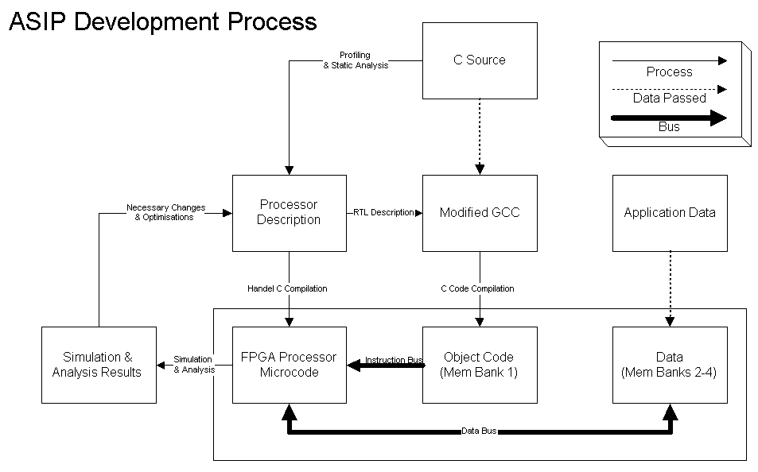
Figure 7-13: ASIP Development Process

C Source Code

The C source code will be an application, which has been designed and written to compile and execute on a generic PC architecture. In the case of our system, this will consist of an MP3 encoder/decoder and a simple public key encryption algorithm. It is essential that the source code is fully functional on the PC and will compile successfully using the Gnu C Compiler, GCC, without error.

Profiling

Profiling will essentially determine which parts of the compiled code are “hot spots”, i.e. where a significant proportion of the execution time is focussed. As this is a complex process, a discussion of the intricacies and methods that will be invoked is contained elsewhere in this document.

Static Analysis

Static Analysis is the process of obtaining a breakdown of the instruction usage for a piece of source code, simply by counting the different instructions for a specific piece of application assembly language. One or more sections of code will be selected to undergo this analysis, from the “hot spots” identified by the profiling process. This code will then be compiled (but not assembled) for the generic MIPS architecture. The aim here is to decide which instructions are most, and least frequently used, so that sections of the MIPS processor implementation we aim to use as a starting point may be removed if deemed redundant. Static analysis will also give an indication of register usage, which can be used to fine-tune the processor model.

GCC

The output produced by GCC will be a three-address format based on RISC-like load-store architecture. In this model, only the load and store operations are able to operate on main memory, with all other instructions operating on registers. GCC already has an implementation to produce MIPS code, which we will use as a starting point for the ASIP. This version also includes performance optimisations for the MIPS processor.

Simulation

The aim of simulation is to ensure the version of the software compiled and run on the ASIP is functionally equivalent to the original software implementation. The outputs of the two programs are compared to identify differences that may signify errors in either the compiler or the processor model. Due to architecture differences, e.g. floating point vs. fixed-point arithmetic, reasonable tolerances and methods of comparison must be identified. This may include subjective metrics such as listening tests as well as more rigidly defined comparisons. As we are not expert listeners, we will also use a direct comparison with some statistical analysis of the data to determine the average deviation.

Further Instruction Set Analysis

Initial analysis will focus on minimising the number of instructions performed in total by the processor for common instruction sequences. It is envisaged that the development cycle of the processor model will terminate when one of two outcomes occurs. Either the maximum number of gates on the FPGA will be reached, or the processor will have developed such that any modifications to the instruction set will have a detrimental effect on the execution speed. This will be determined with rigorous benchmarking.

Changes & Optimisations

Changes that will be made to the processor model will take two forms.

- Mandatory changes signified by incorrect results being produced from simulation. These are likely to be caused by errors in the conversion of GCC for the processor model, or by errors in the Handel-C implementation of the processor model. These changes are necessary for the successful operation of the system.

- Optimisation changes identified during analysis of the code. These changes are likely to be in the form of removing redundant instructions, or perhaps making minor adjustments to the processor model itself in order to improve efficiency and resource usage. They also may include combining simple operations into Very Long Instruction Word (VLIW) operations to exploit a higher degree of parallelism.

Changes and optimisations will occur during each iteration of the development process. This will result a processor model that will evolve rather than the end artefact being initially fully designed.

Hardware /Software Partitioning Design

Walkthrough:

This route exhibits characteristics different from the ASIP route. The emphasis is on partitioning the application into a software part and a hardware part managed by a central component, or an operating system, whereas in the ASIP route, the executable is simulated on the FPGA rather than executed.

The profiling results will also be used here. Once the “hot-spot” functions have been discovered, manual hardware/software partitioning is used to filter components into two sets. One set will run on host machine’s CPU (software components), and the other will run on the FPGA (hardware components).

Due to the partitioning process, some components in software may require results from hardware components or vice versa. The implication of this is the need of process synchronisation and inter-process communication. For this, a core component, which works like an operating system, scheduling components running on software mode and hardware mode, is utilised. Typically, this core unit will have to manage task pre-emption on the hardware unit in case a higher priority component arrives at the system or when the task itself completes execution.

Finally, the system is co-simulated (same as ASIP route) to obtain design verification and performance results, which will be fed back into the design process for the next iteration.

Figure 8.1 shows the design process.
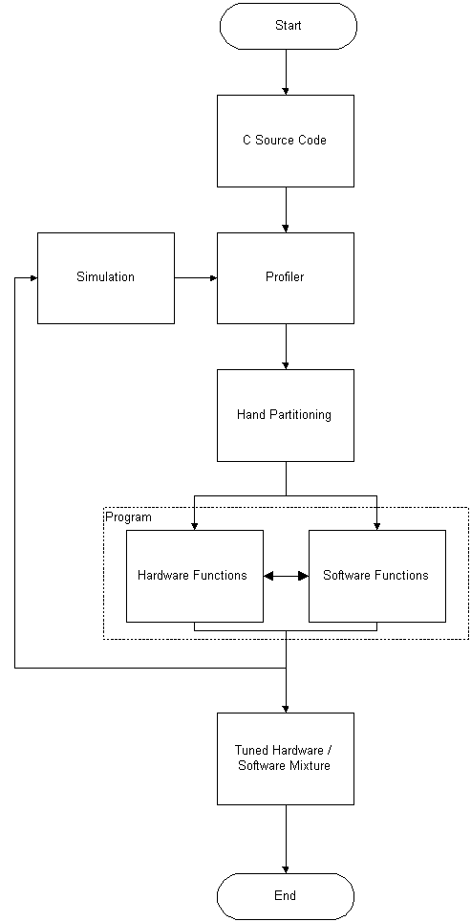
Figure 8-14: Partitioning Design Route

Profiling:

The development process starts by code compilation and a test run to ensure the compiled software works correctly. Next, the application code is profiled to determine the function(s) that consume most of the CPU time. Profiling will require different data inputs to get a view of the average execution time of the functions. Once the “hot spot” functions have been identified, the source code will be partitioned. The partitioning must consider the limitations and advantages of using the FPGA.

Before portioning, another pass through the application code, this time using line frequency profiling, will show the hit rate and timings of lines of code in each “hot spot” function. The reason this step is crucial, is that hit rates and timings of separate lines provide an insight to the bottlenecks of the “hot spot” function, resulting in possible potential improvements. See appendix performance measurements for possible methods of program optimisation.

The same cycle will repeat through iterative co-simulation, testing and verifying the application is ran optimally. It is important to focus on size optimisation as well as speed, due to the aim of utilising FPGA gates and memory to the maximum.

Hardware/Software Partitioning:

Partitioning will be made according to certain rules that will be mentioned later.

Hardware/Software Scheduling:

One approach to scheduling is to use concurrency constructs within a programming language, to achieve process synchronisation, control data access in shared memory, and access to shared components. The important issue here is how do we schedule processes, what happens to processes running on the FPGA, what happens to data in the application, how do we decide which process must continue running when there are other equally important processes waiting for execution… These must all be fulfilled and at the same time, the order of execution must be enforced such that the correct result is always achieved.

A central management component is one option for these issues. Considerations for such a component include, scheduling strategy: round robin, pre-emptive scheduling, priority based, etc., and control synchronisation: the system will require access to memory data locations and code locations and this must be done in an orderly manner so data integrity is maintained.

From these arguments, this core component would be built in a form a simulated operating system that controls process inter-communication between functions executing on the host machine’s processor and hardware functions executing on the FPGA component. Figure 8.1 below illustrates an example of the behaviour desirable for the core component of the DEEP-3 system.

Figure 8.2: Scheduling
P1
P2
P3
P4
P5
P6
a - Typical view of the system with
a number of process running concurrently
P1
P2
P3
P4
P5
P6
b - OS removes P4 from FPGA and replaces it with P5
Software Components
Hardware Components
OS
Data Area
Code Area
FPGA Memory
Banks
In figure (a) shown an illustration of a system with some process running on one processor. A simple trace into the system shows that routes P1, P2, P5, P4 run simultaneously with P4, P6. Assuming that profiling and partitioning have been carried out we arrive at the system in state (b) Profiling and partitioning has been decided, with an OS running on top of the processes in the system. Assuming P1 and P4 start executing simultaneously, P1 completes and starts P2, which gets to a point where it needs results from P5, but P4 has not yet finished. So in essence, the OS stores data and marks the rest of the code that needs completion by P4 and reserves it in appropriate locations of the memory banks for later use. Then runs P5 on the FPGA. Once P5 completes execution and results passed to P2, which completes its execution. However, since P5 has completed its execution, the system needs to complete P4 and run P3 as well. Fortunately in this case, P4 will be scheduled back on the FPGA and OS schedules P3, which will run concurrently with P2 on the software side and with P4 on the hardware side. Finally P6 will execute to complete the
program execution.

Naturally, with such example, it would be necessary to mention how it is done as well as what data is needed by the OS to processes such advanced operations. A strategy for this maybe that the OS has a number of resources it accesses to process component scheduling. For example, the OS may keep an up-to-date log file about processes.

Conclusion and Summary:

This report presented a high-level design description of the DEEP-3 project, starting with the front-end application, which included MP3 and cryptography algorithms. First, an overview of the MP3 technology standard was provided, which covered the basic design models. This overview included a walkthrough of the complete process of encoding, storage, decoding and playback. Through a rigorous selection process, LAME was chosen as an encoding algorithm for the project. A further section then briefly described the criteria for adoption of an encryption standard to be used in the application. The standard chosen was PGP.

A mock-up of the proposed User Interface and associated analysis was presented in the fifth chapter of the report.

An overview of the system architecture made up the sixth chapter. This architecture was derived from the initial requirements of the system and analysis of the design models.

The next issue tackled by the report was the methods within which the front-end application will be implemented to collaborate with the FPGA hardware component. First, the document described the ASIP design method, where source code and processor model will be compiled to generate an executable description for the main part of the application addressed to a target processor on the FPGA. Then through simulation, different configurations will be explored to improve performance based on the bottlenecks identified by profiling.

Second, the other method was explained, in which the source code will be profiled and partitioned to generate an executable for both the FPGA and the host CPU. Again, through co-simulation process, different results will be obtained to reach reasonable levels of optimisation. Included in this method, a description of an intended core component was given which will resolve hardware and software components inter-communication.

This report aimed to present the strategies to be followed by the DEEP-3 development team during implementation. The next phase of design will involve refinement of this initial view of the system, and design space exploration. The next document will define the metrics to be used in evaluating the design methodologies, as well as providing the initial results from the first iteration of the prototyping loops for these methodologies.

The team will continue to develop their skills and knowledge of the system environment and design tools.

Appendices:

Appendix A - Performance Measurement

Tuning program performance is an important step in the software development cycle. A program that profiles program performance is often used to determine which portions of the code the program spends most of its time in. Sections 2 and 3 provide information about performance measurements and some of the widely used performance metrics. Section 5 outlines performance measurement tools available in a short comparison to their capabilities. Section 6 provides an explanation of certain strategies to follow when attempting program measurement and optimising, which is addressed to the Microsoft Visual C++ IDE.

The need for performance measurement
Performance as defined by The Concise Oxford Dictionary is “a person’s achievement under test conditions …etc”. Abstracting the view from an individual, the subject would be a measurable object that has some functionality towards a defined objective. Performance could be thought of as a field used to assess factors of interest to the mentioned groups above surrounding an object or functionality. This functionality can range from process performance measurements –chemical processes, nuclear processes, mechanical instruments …etc- to a full-scale computer system’s performance. In all cases, the objective raises the root question: “Why do we measure performance?” Naturally, “computer system users, administrators, and designers are all interested in performance evaluation since their goal is to obtain or provide the highest performance at the lowest cost” [33]. There is a big deal of reasons of why performance measurement is needed if addressed to the specific needs of individuals of interest. Below are the general core reasons of the purpose of performance measurement:

- Comparison: Measuring the performance of a number of systems can help in evaluation of the best system. This is typically beneficial for customers and organisations looking for best performance machines or programs. However, in development perspective, it is used to compare several designs to find best performance design. The same would apply for implementation alternatives.
- Performance tuning: Helps in determining the current performance of systems, and whether improvements can be introduced were applicable. For the DEEP-3 Project this category would be the most appropriate, according to project goals.
- Performance control: Maintain the performance of a system within specified limits.

A system can be measured in different ways to produce different results. We may measure a system for speed improvement, I/O monitor, OS operations, kernel, memory access, hardware …etc. The focus of performance should be viewed in the context that the “performance of a system can be discussed only in the context of what the system is required to do.” [32]. Keeping the focus around the DEEP-3 project, the system is required to provide a balance in executing an application on software and hardware elements, focusing entirely on optimising the performance of such a system. Therefore, our interest would be finding the most time consuming functions and concentrate on optimising them.

The rest of the appendix will outline the main methods and techniques used for performance measurements and how results obtained from those methods can be represented in a meaningful way to produce definitive statements about the performance of a system. Finally, an outline of current available performance measurement tools will be presented together with some description of their functionality, advantages and disadvantages.

Performance measurement Methods and techniques
The process of performance evaluation must start with selecting a proper set of parameters upon which the evaluation will be based. These parameters are called performance measures. The evaluation process consists then of the following steps:

- Define performance measures. “What do we want to measure?” and “Why?”
- Determine the quantitative values of performance measures and analyse system performance with respect to system structure and system workload. “What do they mean?”
- Assign qualitative values to different levels of performance measures and assess system performance. “Compare expectation to actual performance”

Assigning a number of performance measures in a scheme is called the workload. Thus we are able to define a workload as a scheme or a collection of performance measures that will sufficiently describe performance bottlenecks in a system and will be bases for tuning. Furthermore, “The effectiveness of a system is described in terms of the capability to process a given workload” [32]. Workload is characterised in three categories, physical which is oriented solely towards the resources and hardware, virtual that is related towards the logical view of a system and finally functional which is application oriented. Elaborating on the functional workload –because of its relevancy to the DEEP-3 project -, its main characteristics are that it is application oriented, system independent and considered difficult to design systematically due to ambiguity. Its applications are mainly competitive procurement, capacity planning and design [34]. Typical performance measure factors are summarised below in terms of high software level – i.e. no considerations are given to I/O calls, CPU measures, memory access, OS operations ...etc, only to user programs and applications:

Hardware Related:

Instruction mix:
Relative frequencies of different types of instructions the system must execute.

Tedious presently because of the complexity of processors’ instruction mix such as, the CISC architecture and the introduction of more complex interactive system components and OS architectures. Mostly for “selection of computer hardware, and design of new processors.” [32]. A measurement tool would count the frequencies of each instruction class as it occurs and records it. Then counters will be viewed in a table like TABLE 1 below. Typical uses of this measurement would be, optimising computational instructions in a scientific system instead of the I/O instructions and the inverse with business oriented system for faster data access. Again, the choice and the use of the results of such a measure is left upon the development team. The table below illustrates such measure:

Instructions | Frequency of Execution, f_{i} | Mean execution time per instruction, t_{i} | Weight | Mean weighted execution time
1 Floating-point add/subtract | 0.04 | 12 | 1 | 0.48
2 Floating-point multiply | 0.08 | 8 | 1 | 0.64
3 Floating-point divide | 0.05 | 8 | 1 | 0.40
4 Move (memory to memory) | 0.10 | 3 | 1 | 0.30
5 Compare | 0.14 | 3 | 1 | 0.42
6 Register to memory-memory to register | 0.18 | 2 | 1 | 0.36
7 Conditional Branch | .20 | 2 | 1 | 0.40
8 Others | .21 | 2 | 1 | 0.42
 | 1.00 | Mean execution time |  | 3.42
TABLE 1 Computing the mean execution time of an instruction mix [34].

This measure would be typically useful in the ASIP design route which will enable the developer to investigate which processor would be most likely suited to such a mix. For instance, where an instruction mix – after optimisation – reveals an intensive use of load/store instruction, the developer may consider introducing a load/store processing architecture. For this specific example, the MIPS processor which has a RISC architecture would be beneficial.

System Effectiveness

Throughput:
Amount of useful work completed per unit of time with given workload. In other terms, this measure could be references as the productivity measure. This measure maybe expressed in many ways, for instance, number of programs executed per units of time, number of instructions executed per unit of time and so on. Throughput can only be described within the context of the workload given. Lets assume X is the throughput, P is the number of programs to be executed and T is the total time (elapsed time) within which the P programs have executed, and then we have X as:

X = P/T; programs per minute r second… etc.

Most importantly about throughput measurement is the consideration that throughput maybe affected by many factors, for example, system software and hardware, overlapping use of components, algorithms and so on.

Relative throughput:
Elapsed time required to process given workload on system S₁ / elapsed time required to process the same workload on system S₂.

Comparison between two systems or two different executions of a program on different machines, or could be on the same machine but with different configurations.

Capability (capacity):
Capacity is defined as the maximum amount of useful work that can be performed per unit of time with given workload. The throughput is usually less than capacity.

Turnaround time:
Elapsed time between submitting a job to a system and receiving the output. “For an individual program, the value of turnaround time is given by P – R, where R is the moment at which the reading in the program begins and P that at which the printing of results is completed. The mean turnaround time for n programs is given by:

$$T_{m}=\frac{1}{n}\sum_{i=1}^{n}{(P_{i}−R_{i})}$$

The mean turnaround time provides an indication of the processing efficiency. It is argued that the weighted turnaround mean and weighted turnaround time are a much more preferred types of measurement representations.

Availability:
“Of a systems is defines as the fraction of time the system is available to service user’s requests” [33]. The inverse of availability is the downtime or when the system is “busy”.

It is utterly important to note that, “performance measures can be specified only with respect to the type and purpose of the evaluated system, its workload, and purpose of evaluation. Performance measures must be well defined since they set a framework for the entire evaluation process” [32]. Note, that the covered system is of an embedded type system where static performance analysis matters. I.e. system is compiled, profiled and resulting measures are accounted for.

Performance analysis tools
There are many profiling tools in the market and industry used for code profiling and program optimisations. However, very few tools exist for visualisation of profiling data. This section outlines the most popular and available tools:

Microsoft Visual C++ 6.0 Profiler:
This profiler is considered one of the simplest and easiest to use due to its full integration in the Microsoft C++ IDE, which gives the advantage of easily setting it up with a project or an application. This profiler provides simple information about an application:

Function timing: measures the time consumed by each function in a program, both on behalf of itself and behalf of its callers. I.e. total function timing including child functions. Function timing maybe the ultimate measure used to highlight speed bottlenecks and can provide a good clue for algorithm improvement.

Function coverage: produces a report on whether a function is called or not. Therefore, and after a number of runs, the code that never executes maybe removed or an algorithm maybe changed.

Line coverage: produces a report that indicates whether particular lines of code are called. Function and line coverage help in finding the code in an application that is never called Dead code.

Perhaps the level of detail provided maybe adequate for simple applications rather than complex ones where the application requires constant access to external components such as DLLs. Providing certain switches to this tool enables a view of a trace of the program – none graphical – which highlights critical paths in program execution tree provided correct interpretation.

HiProf 1.01:
HiProf is developed by TracePoint Technology. A tool which offers a very good balance of features and ease of use. It is able to provide performance information for each line of source code and for external components. HiProf includes graphical hierarchical view, which provides a way to see detailed performance information for each parent function in conjunction with each child.

Visual Quantify:
An advanced profiling tool developed by Pure Atria Corp and Rational that profiles C++ and Java applications.

Although its profiling and code insertion can be time consuming it provides detailed information about program measurements including external components such as DLLs and ActiveX controls, threads in the program, operating system, hardware used to perform the test and a log on the modules that were instrumented.

The important feature of this tool is the call graph window, which shows a graphical representation of the execution flow of the application instrumented. The call graph highlights the longest execution path in the application so that spotting bottlenecks is simple. This graph provides many different features as well; for example one can set the view on the most time consuming functions. A developer can navigate through the different paths of execution collection different information about the trace although navigation may be awkward due to the enormous paths.

Other features are the function list window that detailed information about functions. One can view information of a function including child times or excluding them.

The developer can perform advanced configurations on the source code such as selection of a number of functions to be profiled or collection of information from each line of the code individually or doing so using functions.

 | PROS | CONS
Microsoft Visual C++ 6.0 | Already included with the compiler.  Well integrated with the Visual C++ IDE  Good performance | Cannot profile external components
HiProf 1.01 | Profiles external components.  Offers very detailed parent/child performance information.  Offers many advanced features, such as excluding functions. | Hierarchical View is not as intuitive as it could be.
Visual Quantify | Profiles external components.  Call Graph is good for showing parent/child relationships and execution timeline.  Offers many advanced features, such as excluding functions. | Not expensive considering the variety of options the developer has $750.  Detail screen navigation is awkward.
Profilers at a glance [36]

Developing Optimised Code with Microsoft Visual C++ 6.0
Usually the most wanted forms of optimisations in program are concentrated in speed and size. There are many ways to make code run quickly. Often, the controlling factor for the speed of a program is the algorithm used, rather than any optimisations made by the compiler. Consider the comparison between array lists and dynamically linked lists. A search algorithm used on an array is faster because the array will probably reside in RAM, whereas linked list will be scattered in memory and may incur several page faults resulting in heavy penalty in timing.

Speed Optimisations

Changing the order of execution:
By removing repeated patterns in an expression to the minimal. For example:

y= a * (y1 – avg) + b * (y1-avg) + c * (y1-avg);

Can be turned into

temp = (y1-avg);
y = a * temp + b * temp + c * temp;

And more optimised into

temp = (y1 – avg);
y = temp * (a+b+c);

From 3 multiplications, 2 additions and 3 subtractions to 1 multiplication, 2 additions, 1 subtraction. Imagining the same expressions (optimised and non-optimised) running inside a loop of 1000 iterations, the optimisation has improved speed by %66.

Copy propagation and dead store elimination:
Work to remove unused intermediate variables from the calculation stream, improving both size and speed. By doing so a load, store and memory location is saved for each variable optimised away. The benefits can be even greater when applying this technique with structures and complex objects. An instance of such a situation is illustrated below:

int foo(struct S sp) { struct S sa = sp; return sa.i}
Which can be turned into
int foo(struct S sp) { return sp.i}

Improving loop invariant:
In some loops we may assign an each array element a constant value. So for a large number of loop executions the constant generation can be a costly operation and should be pre-calculated to save time.

For (I = 0; I < 1000; I++)
A[I] = a + b;

Can be turned into
T = a+b;
For(I = 0; I<1000; I++)
A[I] = t;

Variable location:
Considering the same example as above, if we kept the value of t inside a register rather than memory, then for 999 load operations, we load its value from a register rather than memory, which is a great deal faster. Register allocations are used where a variable is used heavily in a program.

Loop unrolling:
In tight inner loops, a significant percentage of the CPU time can be spent doing counter arithmetic and conditional jumps. Loop unrolling allows turning the loop into straight-line code.

Instruction Order:
On modern pipelined processors, instruction order can make a huge difference in execution speed, because addresses can be pre-fetched if the order is right.

Dual pipeline considerations:
Processors with dual execution pipelines, such as Intel Pentium, can get tricky in optimisation. Code that manages to keep both Pentium execution pipelines filled and executing simultaneously can run up to twice as quickly as code that does not do.

Size Optimisations

Code size, although may not seem to be so important these days with standard 128MB of RAM and 512KB of Processor cache, can make a huge difference in running an application especially on a multi-tasking environment such as Windows. Generally, slow code happens because of two main reasons, cache miss and page faults. Cache miss causes a minor delay in time, but page fault maybe a serious delay that must be avoided. Missing a cache can only cause a few cycles of delay, in which the fetching will occur in physical memory RAM. On the other hand, in a page fault, the code would have to be fetched from the disk. In an Intel Pentium II 400MHz this causes 4,000,000 cycles (around 10 milliseconds). Not to forget, multiple occurrences of such faults in loops can cause a serious delay in an application, which can be avoided by applying some of the optimisation techniques discussed earlier in section 6.1. It is important to note that “the optimum strategy for most window programs is to favor size for most code and to favor speed only for hot spots in the code” [37].

Other optimisation methods:

The C++ compiler is an optimiser itself, which uses a great deal of techniques to optimise program code. Delay loaded DLLs, run-time Library and System API options, For more details about these topics refer to [37].

Appendix B: MP3 file header

Here is a presentation of the frame header content. Characters A to M are used to indicate different fields. In the table below, you can see details about the content of each field.

AAAAAAAA AAABBCCD EEEEFFGH IIJJKLMM

Sign | Length  (bits) | Position  (bits) | Description
A | 11 | (31-21) | Frame sync (all bits must be set)
B | 2 | (20,19) | MPEG Audio version ID  00 - MPEG Version 2.5 (later extension of MPEG 2)  01 – reserved  10 - MPEG Version 2 (ISO/IEC 13818-3)  11 - MPEG Version 1 (ISO/IEC 11172-3)
C | 2 | (18,17) | Layer description  00 - reserved  01 - Layer III  10 - Layer II  11 - Layer I
D | 1 | (16) | Protection bit  0 - Protected by CRC (16bit CRC follows header)  1 - Not protected
E | 4 | (15,12) | Bitrate index  NOTES: All values are in kbps  V1 - MPEG Version 1  V2 - MPEG Version 2 and Version 2.5  L1 - Layer I  L2 - Layer II  L3 - Layer III  "free" means free format. The free bit rate must remain constant, and must be lower than the maximum allowed bit rate. Decoders are not required to support decoding of free bit rate streams.  "bad" means that the value is un-allowed.  MPEG files may feature variable bit rate (VBR). Each frame may then be created with a different bit rate. It may be used in all layers. Layer III decoders must support this method. Layer I & II decoders may support it.
  bits | V1,L1 | V1,L2 | V1,L3 | V2,L1 | V2, L2 & L3
  0000 | free | free | free | free | free
  0001 | 32 | 32 | 32 | 32 | 8
  0010 | 64 | 48 | 40 | 48 | 16
  0011 | 96 | 56 | 48 | 56 | 24
  0100 | 128 | 64 | 56 | 64 | 32
  0101 | 160 | 80 | 64 | 80 | 40
  0110 | 192 | 96 | 80 | 96 | 48
  0111 | 224 | 112 | 96 | 112 | 56
  1000 | 256 | 128 | 112 | 128 | 64
  1001 | 288 | 160 | 128 | 144 | 80
  1010 | 320 | 192 | 160 | 160 | 96
  1011 | 352 | 224 | 192 | 176 | 112
  1100 | 384 | 256 | 224 | 192 | 128
  1101 | 416 | 320 | 256 | 224 | 144
  1110 | 448 | 384 | 320 | 256 | 160
  1111 | bad | bad | bad | bad | bad
F | 2 | (11,10) | Sampling rate frequency index
  bits | MPEG1 | MPEG2 | MPEG2.5
  00 | 44100 Hz | 22050 Hz | 11025 Hz
  01 | 48000 Hz | 24000 Hz | 12000 Hz
  10 | 32000 Hz | 16000 Hz | 8000 Hz
  11 | reserv. | reserv. | reserv.
G | 1 | (9) | Padding bit  0 - frame is not padded  1 - frame is padded with one extra slot  Padding is used to exactly fit the bitrate.As an example: 128kbps 44.1kHz layer II uses a lot of 418 bytes and some of 417 bytes long frames to get the exact 128k bitrate. For Layer I slot is 32 bits long, for Layer II and Layer III slot is 8 bits long.
H | 1 | (8) | Private bit. This one is only informative.
I | 2 | (7,6) | Channel Mode  00 - Stereo  01 - Joint stereo (Stereo)  10 - Dual channel (2 mono channels)  11 - Single channel (Mono)  Note: Dual channel files are made of two independant mono channel. Each one uses exactly half the bitrate of the file. Most decoders output them as stereo, but it might not always be the case.  One example of use would be some speech in two different languages carried in the same bitstream, and then an appropriate decoder would decode only the choosen language.
J | 2 | (5,4) | Mode extension (Only used in Joint stereo)  Mode extension is used to join information that is of no use for stereo effect, thus reducing needed bits. These bits are dynamically determined by an encoder in Joint stereo mode, and Joint Stereo can be changed from one frame to another, or even switched on or off.  Complete frequency range of MPEG file is divided in subbands There are 32 subbands. For Layer I & II these two bits determine frequency range (bands) where intensity stereo is applied. For Layer III these two bits determine which type of joint stereo is used (intensity stereo or m/s stereo). Frequency range is determined within decompression algorithm.
  Layer I and II | Layer III
    value | Layer I & II
    00 | bands 4 to 31
    01 | bands 8 to 31
    10 | bands 12 to 31
    11 | bands 16 to 31
    Intensity stereo | MS stereo
    off | off
    on | off
    off | on
    on | on
K | 1 | (3) | Copyright  0 - Audio is not copyrighted  1 - Audio is copyrighted  The copyright has the same meaning as the copyright bit on CDs and DAT tapes, i.e. telling that it is illegal to copy the contents if the bit is set.
L | 1 | (2) | Original  0 - Copy of original media  1 - Original media  The original bit indicates, if it is set, that the frame is located on its original media.
M | 2 | (1,0) | Emphasis  00 - none  01 - 50/15 ms  10 - reserved  11 - CCIT J.17  The emphasis indication is here to tell the decoder that the file must be de-emphasized, i.e. the decoder must 're-equalize' the sound after a Dolby-like noise suppression. It is rarely used.

Appendix C: Music clips for test the MP3 encoder

Adated from Do MP3 encoders sound different? by Will Ryu

Test Data

"Razumosvsky" Beethoven Quartet from Key to the Quartets, performed by Emerson String Quartet

String instruments are harmonically rich and display a wide array of tonalities and dynamics. In addition to their distinctive sound, aggressive bowing brings out sharp transients with complex overtones which might make for difficult encoding.

"Setting Sun," from Dig Your Own Hole, Chemical Brothers

This song is a wall of sound from top to bottom. In the upper frequencies there are plenty of percussive tracks, frequency sweeps, and some constant high pitched tones. In addition, there's a deep, gated bass drum that solidly cuts through the music. Plenty here to trip up an encoder.

"Tears in Heaven," from Eric Clapton Unplugged, Eric Clapton

This recording has great "presence," in the sense that it gives you a feeling of being right there during the recording. On my stereo the imaging is wide and deep, with well defined space between instruments. Also, there are plenty of audio cues to listen for when doing critical comparisons. At the beginning of the track you can hear someone’s foot tapping with short but distinctive reverberations coming from the wooden stage. The guitars produce sharp and clean attack transients. Clapton sings with backup singers, and vocal tracks can be revealing. Finally, there's a high pitched bell with a long and clear decay.

Test results

"Razumosvsky"

In the "Razumosvsky," at 128 kbs, there is a noticeable softening of the attacks of the strings with all of the encoders. With the Blade and LAME encoders, the viola at one point in the track produced a "boxy" tonality that wasn’t apparent on the CD or with the other encoders. The Xing encoder sometimes sounded a bit "whispy" on the softer, quickly-bowed sections and had a bit of metallic tonality in general. FhG was the best of this bunch at 128 kbs, but still not nearly CD quality.

The sound improved a great deal at higher bit rates, as is to be expected. The boxiness of the Blade and LAME encoders was much less prevalent at 160 kbs and disappeared at 192 kbs. The Xing remained whispy at 160 kbs, but sounded quite good at 192 kbs. I’d be hard pressed to pass a double blind comparison of these encoders at 192 kbs with this test track. I was actually a bit disappointed because I thought the Razumosvsky track would be more revealing.

"Tears in Heaven"

"Tears in Heaven" produced a different set of artifacts. In the very beginning of the track you can hear high frequency mike or pickup noise. On the CD it sounds like normal, uncorrelated noise, but the MP3s produced a swirling and swishing artifact. Also, the foot tapping lost its eerily real presence and the bell lost its clean decay. For lack of a better description, the Blade encoder sounded a bit "crunchy" in the high end, which might have been caused by an excessive brightness in the sound. The Fraunhofer encoder produced a surprisingly harsh sounding attack on the guitar; it remained quick and sharp, but was artificially crisp and accentuated. Nevertheless, the Fraunhofer encoder produced the best sounding vocals and, again, was arguably the best sounding of the bunch at 128 kbs.

Many of the aforementioned artifacts disappeared at higher bit rates. At 160 kbs the FhG encoder lost the harsh guitar sound. In fact, most of the swishing and swirling high-frequency artifacts lessened at 160kbs with all the encoders. Nevertheless, the "you are there" imaging and presence was absent, and the tonality in the upper register was not quite right.

I could hear even more concrete improvement by stepping up to 192 kbs. The high frequency tonality especially improved. For example, the percussive bell near the start of the song decays cleanly. At 256 kbs I don’t think I could hear differences between encoders, but none of them quite reached CD quality. It was actually the foot tapping that gave the encoded tracks away. Listening to the CD, you can almost see the shoe tapping the wooden stage (I’m not kidding!). Listening to the encoded tracks, you could only hear it.

"Setting Sun"

"Setting Sun," by the Chemical Brothers, was a more revealing test track than I initially thought it would be. In general, the sound was harsh and unpleasant for all the encoders at 128 kbs. There's a lot of high-frequency information in this song, and it might have given the encoders some trouble. Specifically, all of the encoders had difficulty reproducing one percussive track (it sounds like a pitch-shifted snare drum). The Blade encoder was the worst offender, adding a click or a knocking sound to this track. This was a gross enough deviation from the sound that I would call it an encoding error rather than just a general MP3 artifact (this went away at 160 kbs). The harshness remained at 160 kbs, but things were much cleaner at 192 kbs. In addition to the high end harshness, the mid register sounds became unfocused and diffuse at low bit rates. Again, this might have been caused by problems with encoding the high frequency overtones. The distinctive bass drum beat sounded fine at 128 kbs and above.

References
- http://www.iis.fhg.de/amm/techinf/layer3/index.html (sited: 20/ 11/ 2001)
- Davis Pan, A Tutorial on MPEG/ Audio Compression, IEEE Multimedia Journal, Summer 1995
- An Introduction to MPEG Layer-3, K. Brandenburg, H. Popp, , Fraunhofer Institut fur Integrierte Schaltungen (IIS) http://www.mp3-tech.org/ (sited: 20/ 11/ 2001)
- MPEG Audio Layer I/II/III frame header, http://www.mp3-tech.org/programmer/frame_header.html, (sited: 20/ 11/ 2001)
- http://www.mp3-converter.com/mp3codec/mp3_anatomy.htm (sited: 20/ 11/ 2001)
- www.id3.org/mp3frame.html (sited: 19/ 11/ 2001)
- Guy Hart-Davis, Rhonda Holmes, MP3: I didn’t know you could do that, SYBEX Inc, 1999
- http://www.dictionary.com/cgi-bin/dict.pl?term=stereo (sited: 10/ 11/ 2001)
- http://csunix1.lvc.edu/~snyder/ovrsamplng2.html (sited: 11/ 11/ 2001)
- J.O. Smith and P. Gossett, "A Flexible Sampling-Rate Conversion Method," Proc. IEEE ICASSP, vol. 2 , pp. 19.4.1-19.4.2, San Diego, March 1984.
- Single Supply Dual 16-bit Audio DAC, AD1866 Data Sheet, Analog Devices, Rev. 0.
- Generating Instruction Sets and Microarchitectures from Applications, Ing-Jer Huang and Alvin M. Despain, Dept of Electrical Engineering – Systems, University of Southern California (Date unknown).
- MIPS32 Architecture for Programmers volume I: Introduction to the MIPS32 Architecture, MIPS Technologies Inc. (March 2001).
- Mp3 compression, Andrei Gule, http://www.digit-life.com/articles/mp3comp/index.html, ( sited: 11/11/2001)
- Research quality of coding sound by different mp3 encoders, Aleksey Lukyanov http://www.digit-life.com/articles/mp3quality/index.html (sited: 11/11/2001 )
- OGG vs. LAME, Andrei Aspidov, http://www.digit-life.com/articles/oggvslame/index.html, (sited: 11/11/2001)
- Encoder Quality Comparison 1.8.2, December 16, 1999. http://www.raum.com/mpeg/reviews_quality.html (sited 11/ 11/ 2001)
- Which is the best low-bitrate audio compression algorithm?, Panos Stokas sited @ http://ekei.com/audio/ (sited: 11/11/2001)
- BladeEnc, Tord Jansson, http://bladeenc.mp3.no/(16/11/2001)
- http://www.iis.fhg.de/amm/download/mp3encman/index3.html
- Do MP3 encoders sound different? by Will Ryu, http://arstechnica.com/wankerdesk/1q00/mp3/mp3-2.html (sited: 19/11/2001)
- Encoder Analysis and Visualisation, Chris Jonson, http://www.airwindows.com/encoders/index.html (sited: 19/11/2001)
- http://www.xingtech.com/ (sited: 19/11/2001)
- http://www.sulaco.org/mp3 (sited: 19/11/2001)
- http://www.r3mix.net/ (sited: 19/11/2001)
- Discussion of Audio Compression, http://fastforward.iwarp.com/ (sited: 19/11/2001)
- http://www.mp3-converter.com/mp3_converter_full.htm (sited: 19/11/2001)
- http://www.mp3-tech.org/ (sited: 11/11/2001)
- http://www.mp3dev.org/mp3/doc/html/modes.html (sited 19/ 11/ 2001)
- http://www.amd.com/usen/assets/content_type/white_papers_and_tech_doc
- http://www.windriver.com/pdf/RC1000_ds_final.pdf (sited 19/ 11/ 2001)
- Svobodova, Liba. Computer Performance measurement and evaluation methods: Analysis and Applications. 1979. American Elsevier Publishing Company, Inc. New York. Pages 1-28, 44, 52-55. ISBN 0-444-00197-2.
- Jain, R. The art of computer performance analysis: Techniques for Experimental Design, Measurement, Simulation and Modelling. 1991. John Wiley & Sons, Inc. Pages 3-73. ISBN 0-471-50336-3.
- Ferrari, D, Serazzi, G, Zeigner, A. Measurement and Tuning of Computer Systems. 1983. Prentice-Hall, Inc., Englewood Cliffs, USA. Pages 9- 48, 174-203. ISBN 0-13-568519-2.
- Hellerman, H, Conroy, T. Computer System Performance. 1975. McGraw-Hill, Inc. USA. ISBN 0-07-027953-5.
- PC Magazine: C++ Code Profilers: Editor’s Choice. Profilers at a glance. http://www.zdnet.com/pcmag/features/profilers/glance.htm (sited: 13/11/2001)
- Developing Optimised Code with Microsoft Visual C++ 6.0. http://msdn.microsoft.com/library/default.asp?url=/library/enus/dnvc60/html/optcode.asp (sited: 13/11/2001)

including their data, point of execution by a measure of a program counter for each process…etc. Basically, some data structures which enable the OS to control processes.
The DEEP-3 Project requires analysis of measurements about the software level only. Examples of such measurements are function timings, instruction types and user responsiveness. These measures are chosen because of the requirements of the project that specify the need for speed up.
Complex Instruction Set Computer

