DECOMPRESSION-ENCRYPTION MP-3

-CONTENTS-

1 – BACKGROUND AND Introduction - 3
1.1 Introduction 3
1.2 Project Overview 3
1.3 Summary of Aims 3
1.4 Background 4
1.4.1 Advantages of re-configurable computing 5
1.4.2 What is ASIP? 5
1.4.3 Why ASIP? 5
1.5 Summary 6
2 -Chapter 1: Functional Overview- 7
2.1 Introduction 7
2.2 System Overview 7
2.3 System walkthrough 7
2.3.1 MP3 Compression 7
2.3.2 Encryption 8
2.3.3 Storage 8
2.3.4 Authentication 8
2.3.5 Decryption 8
2.3.6 Decompression and playback 8
2.4 System Specification 8
2.4.1 Functional Requirements 8
2.4.2 Design Constraints 8
2.4.3 Design Objectives 9
2.4.4 Non-functional Requirements 9
2.5 Summary 9
3 -Appendix A- 10
3.1 Hardware Platform Capabilities and Constraints 10
3.2 Risk Assessment 11
3.2.1 High Risk 11
3.2.2 Medium Risk 11
3.3 Design Routes 13
4 REFERENCES 15

– BACKGROUND AND Introduction -

Introduction

The purpose of this first chapter is to provide the reader with an overview to this project. It does so by providing a background into the subject of the project and listing the project aims.

Project Overview

The project aims to exploit the power of re-configurable computing to increase the performance of a set of applications. Typical applications of re-configurable machines are in the areas of compression, image processing and encryption. The main objective is to investigate how a re-configurable hardware component can be used to optimise the performance of applications and thus aid a general-purpose processor in its operations and workload. For this project, we will investigate compression/ decompression and encryption/ decryption hence the name Decompression Encryption MP3 (DEEP-3). These represent two distinct areas of re-configurable computing, each with different requirements and complexity, making it easy to produce generalisations about how to optimise a re-configurable system. Various performance measures will be used to analyse the system and the results reported back.

The project aims to produce at least two optimised prototypes by considering two different design routes. The first method uses the conventional approach to hardware-software co-design. The application is partitioned into two groups of processes. One group to be run on the host CPU, a general-purpose instruction set processor, the other set to be run on the re-configurable device. Some inter and intra-process communication will be necessary in order to optimise and synchronise code execution. This is a divide-and-conquer approach, exploiting the concurrency in the application, increasing performance but reducing the re-usability of the system components.

The second method involves the development of a processor model, an application specific instruction set processor (ASIP), on the re-configurable hardware. Object code describing the functionality of the application is then produced on the host and executed on the ASIP. This has the advantage of reducing time to market of future projects because the ASIP design can be re-used in a similar application.

One goal of this project is to measure the complexity of the two design routes and list their pros and cons so that individuals considering designing such a system can be aware of the hurdles involved and can better choose a design route suited to their implementation and maintenance needs.

Summary of Aims

The following is a summary of the project aims:

- To develop two or more prototype FPGA-based systems for encryption and compression of data

- To use at least two different design routes to achieve the first aim

- To benchmark each of the alternative systems produced

- To use the benchmarking results and hardware-software co-design techniques to find the optimum system configuration arising from the design routes.

- To compare and contrast the results of the benchmarking of the prototypes with comparable software only solutions

- To use direct and indirect measures to ascertain the complexity of the two design routes under investigation

- To investigate Hardware-Software Partitioning methods

- To perform all these tasks to budget and to schedule

Background

Before we proceed further, it is important that we define some terminology used in this document as well as provide some useful background into the subject area.

Re-configurable computing was first proposed in the late 1960s by a researcher at UCLA, although it has been around for about 30 years, re-configurable computing is still a relatively new field of study. The decades-long delay had mostly to do with a lack of acceptable re-configurable hardware. Re-programmable logic chips like the Field Programmable Gate Arrays (FPGA) have been around for many years, but these chips have only recently reached gate densities making them suitable for high-end applications. (The densest of the current FPGAs have approximately over one million re-programmable logic gates) With an anticipated doubling of gate densities every 18 months, the situation will only become more favourable from this point forward.

Re-configurable computing systems can be defined as computing platforms whose architecture can be modified by software to suit the application in question. Such a system may take the form of a Field Programmable Gate Array (FPGA) combined with external memories and processors.

However, many system designers are choosing to leave the FPGAs as part of the production hardware (such as Marconi and Lucent). Lower FPGA prices and higher gate counts have helped drive this change. Such systems retain the execution speed of dedicated hardware but also have a great deal of functional flexibility. The logic within the FPGA can be changed if or when it is necessary, which has many advantages. For example, hardware bug fixes and upgrades can be administered as easily as their software counterparts. In order to support a new version of a network protocol, you can redesign the internal logic of the FPGA and send the enhancement to the affected customers by email. Once they’ve downloaded the new logic design to the system and restarted it, they’ll be able to use the new version of the protocol. This is configurable computing; re-configurable computing goes one step further! Re-configurable computing involves manipulation of the logic within the FPGA at run-time. In other words, the design of the hardware may change in response to the demands placed upon the system while it is running. Here, the FPGA acts as an execution engine for a variety of different hardware functions — some executing in parallel, others in serial — much as a CPU acts as an execution engine for a variety of software threads. Re-configurable computing also allows system designers to execute more hardware than they have gates to fit, which works especially well when there are parts of the hardware that are occasionally idle.

Advantages of re-configurable computing

Re-configurable computing has several advantages, first, it is possible to achieve greater functionality with a simpler hardware design.

The second advantage is lower system cost. Systems based on re-configurable computing are upgrade-able in the field. Such changes extend the useful life of the system, thus reducing lifetime costs. Technical obsolescence drives up the cost of systems based on fixed-hardware designs.

The final advantage of re-configurable computing is reduced time-to-market. The manufacturers can ship a product that meets the minimum requirements and add features after deployment. This allows an incremental design flow, a luxury not typically available to hardware designers. In the case of a networked product like mobile telephone, it may even be possible to make such enhancements without customer involvement by sending the updated software via the base-stations.

What is ASIP?

In the project overview we mentioned that one design route will produce an ASIP, but what is it? Application-Specific Instruction-set Processors (ASIPs) are an emerging design paradigm that offers an intermediary solution between ASICs (Application-Specific Integrated Circuits) and general-purpose instruction processors. Typically, ASIPs consist of custom integrated circuitry that is integrated into a programmable processor core. ASIPs usually feature a small instruction set that contains a selection of standard instructions that are useful in the application, and a number of specialised instructions that take advantage of the custom IC functions. Such specialised instructions might perform filtering, channel encoding and decoding, the possibilities are endless.

Why ASIP?

General-purpose instruction processors (often referred to as GPs) have dominated computing for a long time. However, they tend to lose performance when dealing with non-standard operations and non-standard data not supported by the instruction set format. The need for customising instruction processors for specific applications is particularly acute in embedded systems, such as mobile phones, medical appliances, digital cameras and printers. One way of supporting customisation is to augment an instruction processor with programmable logic for implementing custom instructions and another method is to implement them using FPGAs.
Behavioural Description
ASIC
ASIP
DSP
GP
Most Customised
Least Customised

Advantages of ASIPs include high performance and increased design flexibility, this is because late design changes can be accommodated by updating the application software running on the ASIP.

It has been shown that by using ASIPs, a significant reduction in power consumption in devices can be achieved. For instant, 50% power reduction for ISDN-hands free phone, large instruction word allowed for low clock frequency (France Telecom) and 50% power reduction in GSM application (Alcatel).

Summary

In this first chapter, we have described the project scope and its major aims. We have also provided a brief overview of re-configurable computing and ASIPs. The next chapter will discuss the system in more detail and relate the system specification to the project aims.

-Chapter 1: Functional Overview-

Introduction

In the previous chapter we introduced some concepts about re-configurable computing and gave the aims and rationale for this project. In this chapter we specify the functionality of the DEEP-3 system prototypes. The first section is an overview, the second is a description of the high level modules, the walkthrough of the basic requirements, the penultimate section is a summary of the system specification. The final section is a chapter summary.

System Overview

The system aims to compress sound using an Moving Pictures Expert Group (MPEG) Audio Layer 3 (MP3) file format, which will then be encrypted via hardware and software collaboration into an encrypted MP3 file, and stored. After an authentication process, a user will be able to decrypt the encrypted MP3 file(s) and playback the compressed audio.

One use of such a system is encrypted Voice over Internet Protocol (VoIP).

Figure 1 below shows the operation of the system. (The microphone is just an example input source, others will be used)

Figure 1: Level One System Diagram

System walkthrough

Like most non-trivial software application, the DEEP-3 system can be partitioned into a number of sub-systems. These are MP3 compression, encryption, storage, authentication, decryption, decompression and playback.

MP3 Compression

The encoding process starts by feeding a sound sample into the system. The input sound is compressed using both lossy and loss-less compression techniques to the MP3 standard.

Encryption

Considered the core of the application’s operations, which, as its name suggests, will encrypt the MP3 file using hardware/software collaboration ensuring maximum security of the MP3 file by using a standard encryption algorithm.

Storage

After a successful encryption, the encrypted version of the MP3 file will be written to the local storage capability for distribution.

Authentication

This is the process whereby the system prevents unauthorised users from decrypting the stored file, thereby making the audio available to only the intended user.

Decryption

The decryption process will reverse the encryption process. This process will only occur after successful authentication of the user. Decryption will also try and determine if the encrypted file has been tampered with.

Decompression and playback

The final stage of operation is decompression and playback. Once the file has been decrypted and the system detects that the file has not been tampered with, the audio will be decompressed and played back, assuming suitable resources are available to produce the sound.

System Specification

This section details the functional and non-functional requirements of the DEEP-3 system as well as design objectives and constraints. The requirements were captured from research into existing MP3 codecs, project aims and cost constraints.

Functional Requirements

- The system should compress, then encrypt, input sound
- The encrypted compressed sound should be decrypted, decompressed and played-back on request

Design Constraints

- The system must run, in full or in part, on one Celoxica™ RC1000 development board with the XILINX® Virtex™ XCV1000 FPGA chip (See Appendix for details)
- The function(s) deployed on the FPGA must be written in Handel-C
- The audio sampled by the system should be compressed into MP3 format
- During playback sound should be outputted through speakers/ headphones either directly from the FPGA or via a sound card, if available

Design Objectives

- At least two prototypes should be produced
- At least two different design routes should be explored (in keeping with project aims)
- One of the design routes should produce an Application Specific Instruction Set Processor (ASIP) (See Appendix for details)
- The other design route should partition the application such that part of the application is executed on the FPGA, and the other part on the host CPU (See Appendix for details)
- The prototypes should compress and encrypt the input sound in the same or less time than a similar system running completely on the host CPU
- If possible, each prototype should decrypt and decompress an encrypted MP3 file in the same or less time than a similar system running completely on the host CPU

Non-functional Requirements

- User Friendly – similar controls and functionality (in terms of ease of learning, perceived sound quality at same resolution, and response time during playback) to a leading MP3 codec
- Response Time - The sum of the time for decryption and the decompression process, should be as close to real-time MP3 decoding, on a leading MP3 codec, as possible
- Security – the encryption should be at least the recommended strength for secure communication over the Internet
- If possible, the system should support multiple sound input formats
- The system should ensure that there is a low probability that the encrypted compressed sound file has not been tampered with and the tampering not detected
- If the file has been tampered with, the system should report this to the user and allow the user to decide if to play it or not
- The optimum solution may utilise aspects of each design route.

Summary

In this second chapter, we outlined the behavior of the system under development and the constraints on the development process.

-Appendix A-

Hardware Platform Capabilities and Constraints

One of the major design-decisions taken early in the project was the choice of the re-configurable device. The re-configurable hardware development platform chosen was the RC1000 board from Celoxica™. Celoxica™ describes their board as a “high speed FPGA based parallel computing platform”. The RC1000 board is a “full length 32-bit PCI card”Error: Reference source not found with a programmable clock, Peripheral Component Interconnect (PCI) interface, 8MB of SRAM, which can support any XILINX® Virtex™ BG560 part with up to 2 million system gates. For this application we have chosen the XILINX® Virtex™ XCV1000, from the BG560 range, as the target FPGA. The XCV1000 has 1,124,022 system gates.

The RC1000 system clock can be programmed with frequencies ranging from 400KHz to 100MHz. The maximum frequency of this clock is only half that of the maximum of the XCV1000 so the performance of designs using the RC1000/ XCV1000 combination are limited by this factor. Another performance limiting feature is the PCI interface. The XCV1000 supports both 33MHz and 66MHz PCI bus interface but the RC1000 only supports 32-bit, 33MHz PCI bus. This limits the PCI interface to 132Mbytes/sec bursts.

The 8MB of SRAM is for dynamic data storage and is accessible to both the onboard FPGA and the host CPU. This dynamic memory is organised as four 32-bit wide, 2MB banks (16-bit memory addresses for each bank). “Each of the 4 banks may be granted to either the host CPU or the FPGA in any combination”. For example, the FPGA may access three banks in parallel while the host CPU accesses the fourth.

Finally, “the board is equipped with two industry standard [PCI Mezzanine Card IEEE P1386.1] PMC connectors for directly connecting other processors and I/O devices to the FPGA… and host PCI bus…. A 50-pin unassigned header is provided for either interboard communication, allowing multiple RC1000s to be connected in parallel or for connecting custom interfaces.”Error: Reference source not found

The development tools for the RC1000 include Celoxica™ DK1 Design Suite (with Microsoft C++V4.0 or later compiler) and the XILINX® Alliance Series and Foundation Series software tools and other EDA tools. The software runs on most flavours of Microsoft Windows as we as Intel-based Linux Systems.
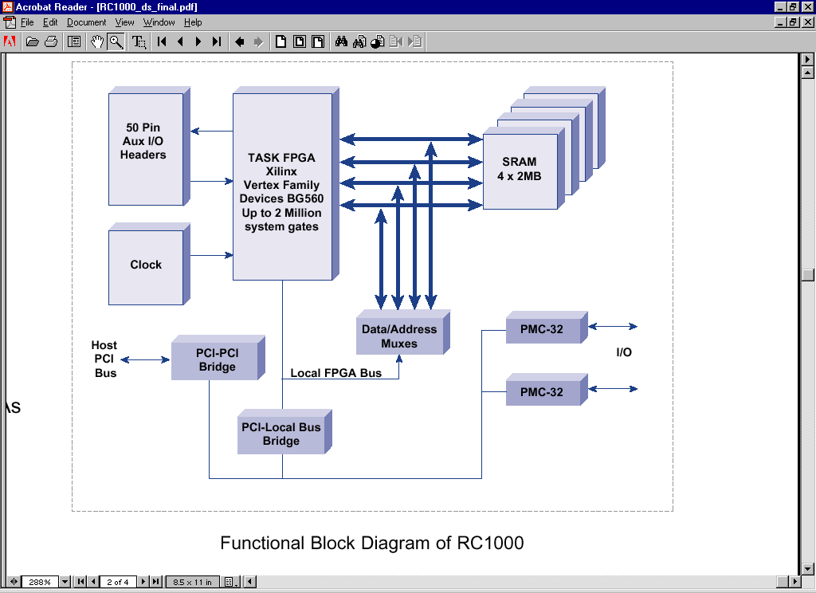
Figure 2 : Functional Block Diagram of RC1000Error: Reference source not found

Risk Assessment

High Risk
These risks need to be considered carefully as they are likely to have a detrimental effect on the project, its timeliness and its overall success.

- Poor Requirements Capture
- Requirements Creep
- Loose specification
- The given project specification is loose and has a very wide scope that needs narrowing.

- Communication
- Meetings at regular times.
- Monday 10am in designated room unless otherwise specified.
- Use Hard Rock Café until room is specified.
- Acknowledge communications such as emails
- Email Receipts

Medium Risk
While not as detrimental to the project as the high-risk category these factors won’t allow complacence. A slap-dash approach to these could move them to the high-risk category.

- Running out of time
- Slow start

- Poor Planning

- Task Complexity
- Handel C ?
- Cryptography ?
- Loss of morale + motivation

- Management
- Resources – 1 FPGA to N? groups.
- Work – Unbalanced workloads
- Too much?
- Too little?

Design Routes
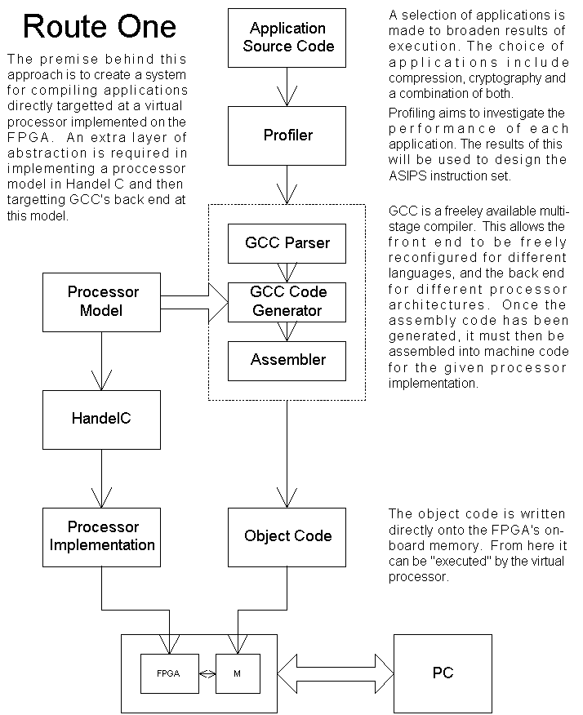

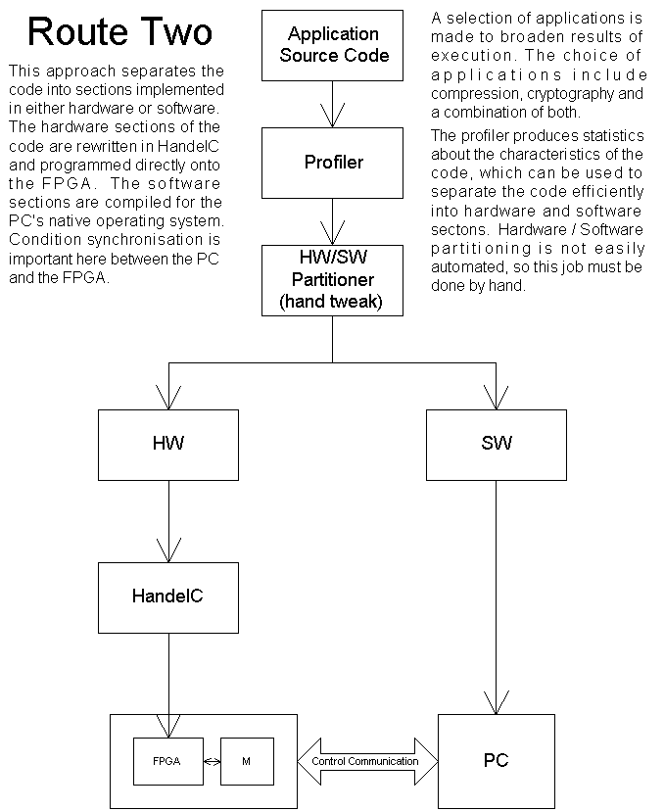

REFERENCES

ACM Crossroads Student Magazine, http://www.acm.org/crossroads/xrds5-3/rcconcept.html
Virtual Computer Corporation, Introduction to re-configurable computing and hardware object, http://www.vcc.com/intro1.html
D. Van Den Bout, J.N. Morris, D. Thomae, S. Labrozzi, S. Wingo, D. Hallman, Anyboard – An FPGA – based Re-configurable Computing System, IEEE Design & Test of Computers, Vol. 9 (1992), No 3, pp.21-30
Reconfigurable Hardware Development Platform – RC1000, Version 1.0, Winter 2001, http://www.celoxica.com
http://www.alphadata.co.uk/dsheet/adc-rc1000.html

