Transcription of ASIP Synthesis class
by Prof.Anshul Kumar

Design of Application Specific
Instruction Set Processor

Introduction to embedded processor:

As the tendency towards more complex electronic systems continues many of these systems are equipped with embedded processors. For example such processors can be found in cars and in audio, video and telecommunication equipment. Essential advantages of these processors include their high flexibility, short design time and in the case of off the shelf processors full custom layout quality. Furthermore they allow an easy implementation of optional product features as well as easy design correction and upgrading. This contrast with the limitations of application specific circuits due to their low flexibility the cost of the design and fabrication of ASIC is still very high. Furthermore this low flexibility makes as short time to market more difficult to achieve. Embedded processors come in different types. We will classify them according to three different criteria: flexibility of the architecture, architectural features for certain application domains, and the form in which the processor is available. The three criteria can be used as dimensions to form a 3D-processor type space. The meaning of these dimensions and their values is as follows:

1. Architectural features for certain application domains

Processors can be designed for restricted or for larger classes of application areas. The two cases considered here are General purpose architecture (GPA) and digital signal processors (DSP). The term general purpose processor is used for processors which do not have particular support for special applications such as Fourier transform or digital filtering.
DSP processors contain special features for signal processing : multiply and accumulate instructions specialized or heterogeneous register sets, multiple ALUs special DSP addressing modes like ring buffers and saturating arithmetic operation. DSPs should also exhibit data independent instruction execution times or should at least exhibit only small variations of the execution time, Otherwise, it would be too hard to predict their real time response. This requirement affects the design of the memory systems as well as the design of arithmetic algorithms.

2. Form in which the processor is available

At every point in time, the design and fabrication processes for a certain processor have been completed to a certain extent. The two extremes considered here are represented by completely fabricated packaged processors and by processors which just exist as a cell or module in a CAD system. The latter is also called core processor. They usually have some architectural flexibility. Core can be instantiated from the library to become part of the design or a part of a heterogeneous chip. In addition to cores, heterogeneous chips may contain RAMs, ROMs and special accelerators.

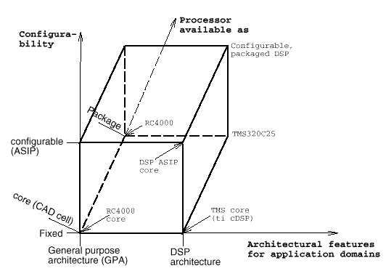
3. Configurability of the processor.

At any point in time, the internal architecture of a processor may either be fixed or still allow configurations to take place. The two extremes considered here are : processor with a completely fixed architectures and application specific instruction set processors (ASIPs).
Processors with a fixed architecture or off the shelf processors have usually been designed to have an extremely efficient layout. Some of them have passed verification procedures, allowing them to employed in safety critical applications. In contrast, ASIPS are processors with an application-specific instruction sets. Depending upon the application, certain instruction and hardware features are either implemented or unimplemented. Also the definition of ASIPs may include generic parameters. By "generic parameters" we mean compile time parameters defining for example the size of memories and the bit width of functional units. ASIPs have the potential of requiring less area or power that off the shelf processors. This is because of the tailor made instruction sets depending upon the requirements. ASIP requirements also push us towards other related issues like processor performance evaluation from models, instruction set extraction and also leads towards need for fast retargetable compilers.

Introduction to ASIP:

Application Specific Instruction set Processors (ASIPs) are in between custom architectures and commercial programmable DSP processors. They allow field and mask programmability but are targeted to a certain class of applications as to limit the amount of hardware (area and power) needed. Consequently, ASIPs are often the best for embedded applications. To increase performance of such an ASIP, custom hardware accelerator data-path(s) can be added, which makes the ASIP a heterogeneous IC architecture.
Sometimes, ASIPs can be parameterized: In this case, the basic architecture of an ASIP is fixed, but it can be customized for a given application by setting a number of different parameters. In this way, word lengths may be adjusted to the required precision, register files may be sized, and available special hardware components, e.g. hardware loop support, may or may not be included. Since these parameters are mostly orthogonal to each other, a range of different configurations of a single ASIP may be available. Consequently, ASIPs are very efficient, but a large number of different compilers would normally be required. In order to avoid this effort, retargetable compilers can be used, capable of generating code for any particular ASIP configuration.

ASIP Design Stages:
- Design starts with the application behavior.
- Evaluate several architectural options.
- Identify hardware functionality to speed up the application.
- Introduce hardware resources for frequently used operations only if it can be supported during compilation.
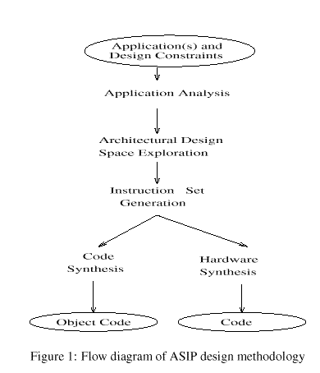
Various methodologies have been reported to meet these requirements. We have studied these methodologies and found that typically there are five main steps followed in the synthesis of ASIPs. The steps are shown in fig. 2

1. Application Analysis : Input in the ASIP design process is an application or a set of applications, along with their test data and design constraints. It is essential to analyze the application to get the desired characteristics/requirements which can guide the hardware synthesis as well as instruction set generation. An application written in a high level language is analyzed statically and dynamically and analyzed information is stored in some suitable intermediate format, which is used in the subsequent steps.

2. Architectural Design Space Exploration : First a set of possible architectures is identified for a specific application(s) using output of step 1 as well as the given design constraints. Performance of possible architectures is estimated and suitable architectures satisfying performance and power constraints and having minimum hardware cost is selected.

3. Instruction Set Generation : Instruction set is to be synthesized for that particular application, and for the architecture selected. This instruction set is used during the code synthesis and hardware synthesis steps.

4. Code Synthesis : Compiler generator or retargetable code generator is used to synthesize code for the particular application or for a set of applications.

5. Hardware Synthesis : In this step the hardware is synthesized using the ASIP architectural template and instruction set architecture starting from a description in VHDL/VERLOG using standard tools. Some consider the processor micro-architecture to be fixed while only synthesizing the instruction set within the flexibility provided by the micro-architecture, while others consider the process of instruction set synthesis only after the parallelism and functionality of the processor micro-architecture is finalized based on the application.

Application Analysis

Typically ASIP design starts with analysis of the applications. These applications with their test data should be analyzed statically and dynamically using some suitable profiler before proceeding further in the design process. The output of APA Application Program Analyzer (APA) includes data types and their access methods, execution counts of operators and functions etc used in application program, the frequency of individual instructions and sequence of contiguous instructions. In one methodology it takes the application as well as the processor architecture as inputs. Using SUIF as intermediate format, a number of application parameters are extracted. These include the average basic block size, number of Multiply-Accumulate (MAC) operations, ratio of address computation instructions to data computation instructions, ratio of input/output instructions to the total instructions, average number of cycles between generation of a scalar and its consumption in the data flow graph etc.

Architectural Exploration

Figure 3 shows a typical architecture exploration block diagram. Inputs from the application analysis step are used along with the range of architecture design space to select a suitable architecture(s).

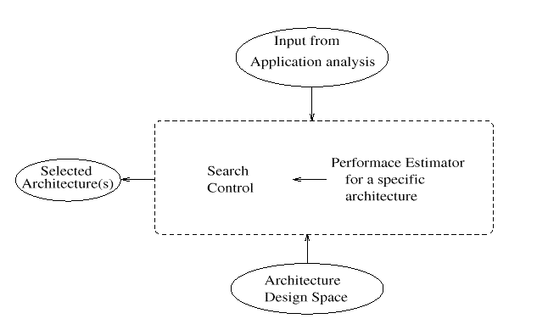
The selection process typically can be viewed to consists of a search technique over the design space driven by a performance estimator. The methodologies considered differ both in the range and nature of architecture design space as well as the estimation techniques employed. Almost all the techniques suggested by various researchers emphasized the need for a good parameterized model for the architecture.
The parameterized architecture model suggested by almost all the people include the number of functional units of different types. The parameters include storage units and interconnect resources also architectural model include issue width, number of branch units, number of memory units, the size of instruction cache and size of data cache etc. in the model.

Performance Estimation

In the literature two major techniques have been used for performance estimation. They are scheduler based and simulator based.

1. Scheduler based: In this type of approach the problem is formulated as a resource constrained scheduling problem with the selected architecture components as the resources and the application is scheduled to generate an estimate of the cycle count. Profile data is used to obtain the frequency of each operation.
Some schedulers take into account not only functional and storage unit resources but also interconnect resources for performance evaluation. It uses a customized GNU C compiler (GCC) to translate a C program into three address instructions. The three-address instruction format is based on a RISC like load/store architecture in which only load and store operations access memory and all other operations work on registers. A parallelizing compiler which is used to extract program parallelism is a fine-grain VLIW compiler which takes serial three-address instruction code produced by GCC as input and generates parallel three-address instruction code in which an instruction may contain more than one operation. The VLIW compiler schedule operations as soon as possible using unlimited resources. An ultra-fine-grain scheduler is developed to exploit hardware parallelism offered by various architectures. It takes either the serial three-address instruction code or the parallel three-address instruction code as input and schedules them on various application specific architectures instantiated from the parameterized architecture model. The output is the parallel control code in which register transfers in each control step are performed concurrently. A simulator is used to mimic the execution of the serial three-address code, the parallel three-address codes as well as parallel control code to obtain performance metrics.
Another one is resource constrained scheduler that estimates the number of clock cycles, given the description file of the target processor architecture, application timing constraints and the profiling data. A key feature of this list scheduler is its capability to reflect the flexibility of the instruction set to handle concurrency. Processor selector rejects processors, which do not meet the constraints.
During architecture evaluation various optimization of the application model need to be done in order to obtain a more accurate metric of the application over a wide variety of issues. The optimizations considered include optimized multi-operation pattern matching (e.g. multiply-accumulate), address mode optimization (e.g. auto-update, circular buffer), loop optimization (e.g. pre-fetched sequential loads), rescheduling within basic blocks, loop unrolling, software pipelining etc. The flow diagram of the estimation scheme followed in general is shown in fig 4.
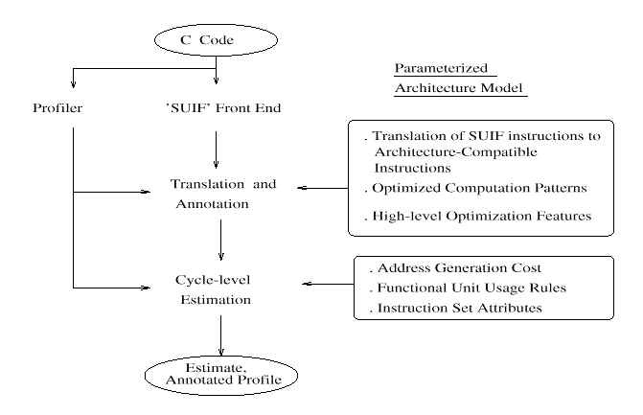
One of the important features of the architectural models used is that it captures the differentiating capabilities of the instruction set and special functional resources, rather than the complete specification required for code synthesis or simulation. Because our requirement is to design an Application Specific Architecture, removing redundant instructions thereby reducing control unit area and on-chip memory by reduced instruction code sizes.

2.Simulator based:
In this method a simulation model of the architecture based on the selected features is generated and the application is simulated on this model to compute the performance. The simulator, by using pre-defined modules and the architecture description, reports performance and statistics about resource utilization. Its engine is an event-driven algorithm also supporting various memory hierarchy structures (data-cache, instruction-cache, bank interleaving, etc.). The application is translated into an intermediate code, composed of simple instructions directly expressing primitive hardware functionalities. Optimization techniques such as loop unrolling, data-dependency analysis, variable renaming and loop interchanging, are further applied in order to increase the degree of parallelism. A sequential code simulation is then performed, in order to validate the code, and to extract some early features, which can perform preliminary architectural choices. For instance, frequently executed sequence of instructions can be substituted by the introduction of new instructions. Simulators could also be used to obtain power dissipation issues of the processor. Measured run-times of benchmarks through simulations are used to compute the energy based on the power model. The power dissipation numbers are normalized with respect to baseline machine power dissipation.

Search Control:
Algorithms for searches range from branch-and-bound to exhaustive over a restricted domain. After search control the output is a smaller subset of processors. Processor description files of this restricted range of processors are supplied to the performance estimator which exhaustively explores this set. The search space is reduced, by eliminating machine configurations not satisfying given area constraint and those that are dominated by at least one another machine configuration and branch-and-bound algorithm is used to select the optimum processor.

Instruction Set Generation:
In this class of techniques, instruction set is synthesized for a particular application based on the application requirements, quantified in terms of the required micro-operations and their frequencies.
An ASIP is usually specified by its instruction set and an abstract description of its data-path. The detailed description of the data-path with all connections is normally not available, nor is a description of the controller or micro-sequencing logic. Traditional instruction selection techniques use tree pattern matching. The set of template patterns is (manually) extracted from the instruction set and the graph representing the intermediate code of the application is concerned by these patterns. For machines with a set of interchangeable general purpose registers, tree pattern matching based on the dynamic programming method ensures optimal code.
In contrast with early processors where each instruction resulted in one template pattern, horizontally microcoded processors and also recent (RISC) prallelism in their instructions. In this case, using template patterns, which each cover a complete instruction, has several drawbacks. The resulting patterns are rather large, which decreases the probability of matching; the number of possible patterns also grows too high, which slow the pattern matcher down. The procedure could be direct generation of Instruction namely instruction synthesis or Instruction set selection

Instruction Synthesis approach : Huang and Despain integrated problem of instruction formation with scheduling problem. Simulated annealing technique is used to solve the scheduling problem. Instructions are generated from time steps in the schedule. The formulation takes the application, architecture template, objective function and design constraints in the input and generates as outputs the instruction set, resource allocation (which instantiates the architecture template) and assembly code for the application. This approach is shown in fig. 5

Instruction Selection In this class of techniques a superset of instructions is available and a subset of them is selected to satisfy the performance requirements within the architecture constraints.
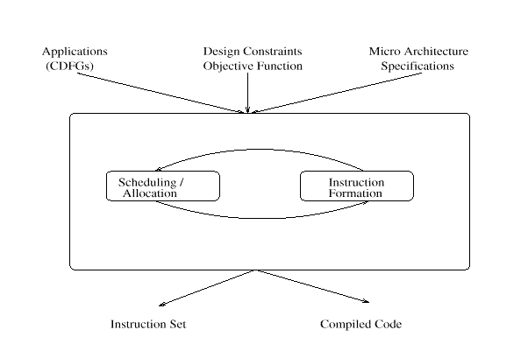
Instruction set can be divided into two groups: operations and functions. It is relatively easy for a compiler to generate instructions corresponding to operators used in C language compared to those, which corresponds to functions. It is because that the full set of operations is already described, but the full set of user-defined functions is not known a priori. They further divide the set of operations into two subgroups primitive operators and basic operators. The set of primitive operators is chosen so that other basic operators can be substituted by a combination of primitive operators. Thus they have classified functionalities as follows.
- Primitive Functionalities (PF): Can be realized by a minimal hardware component, such as ALU and shifter.
- Basic Functionalities (BF): Set of operations used in C except those included in PF.
- Extended Functionalities (XF): Library functions or user defined functions.
The intermediate instructions are described as primary RTL, basic RTL, and extended RTL respectively for these classes. Generated ASIP will include hardware modules corresponding to all of the primary RTL, but only a part of the basic RTL and extended RTL. Selection problem is formulated as an integer linear programming problem with the objective to maximize the performance of the CPU under the constraints of the chip area and power consumption. The branch-and-bound algorithm is used to solve the problem.

Code Synthesis
The work reported has followed two different approaches for code synthesis. They are re-targetable code generator and compiler generator.
1. Retargetable Code Generator: Taking architecture template, instruction set architecture (ISA) and application as inputs, object code is generated (fig. 6). All these approaches try to address following sub-problems while synthesizing instructions
(a) Instruction mapping: Instruction patterns are mapped to CDFG of given application using tree or graph pattern matching technique and an optimal cover is formed.
(b) Resource allocation and binding: Resources like registers, memory, FUs, buses etc are allocated and corresponding bindings are performed.
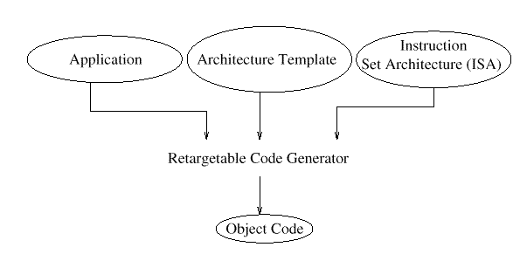
(c) Scheduling: Instructions are scheduled for execution.

2. Compiler Generator: Taking architecture template and instruction set architecture as the inputs, a retargetable compiler is generated. This is used to generate object code for the given application written in a high level language (fig 7)

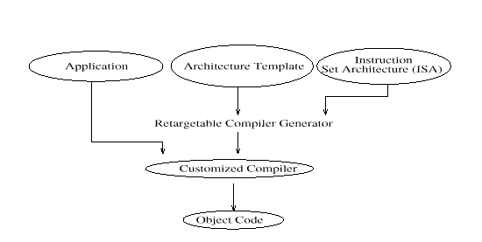
A compiler is said to be retargetable, if it can be applied to a range of target processors. Actually we can distinguish between different level of effort for switching to a new target:
- A high effort is required for portable compilers. Porting a compiler to a new target possibly includes rewriting some parts of the compilers.
- More precisely than above, we say that a compiler is retargetable if it includes almost no processor specific code. The characteristics of the target processor must be captured in separate target specific descriptions.

Need for retargetable compilers:
1. Retargetable compilers are required to support using of ASIPs. Many different instruction sets can be defined by choosing values for the generic parameters of ASIPs. For each set of values, there will possibly be only a small number of designs. For this small number, it will not be economically feasible to design a specialized compiler. So, there should be a retargetable compiler that can generate code for all legal value sets of generic parameters. As far as ASIPs are concerned, no retargetability for very different processors is required. Retargetability within the range of parameters is sufficient.

Why do we need ASIPs?
The main reason for ASIPs is that embedded systems require maximum efficiency that can only be obtained through customization. It has been observed that customization of processors results in more computations per Watt than can be achieved for standard processors. Fully application-specific hardware (ASIC) would achieve a even higher number of computations per Watt, but ASICs lack flexibility. Hence, ASIPs are a good compromise between power consumption and flexibility. Due to their low power consumption, it has been observed that first generation products are sometimes implemented with standard processors and these are later replaced by ASIPs in second generation products.
2. For embedded systems, there is a large range of applications. This range includes, for example, health care applications in which the systems are inserted into the human body, applications in telecommunications and applications in transportation systems. Due to the large variety of applications, a large variety of processors are also required. Due to the mutual dependencies between instruction set and micro-architecture, we believe that there will be different instruction sets, each of which will provide a good match for some applications. This means that we also need compilers for different instruction sets, which are used for small or medium number of applications. This will be economically feasible only if compilers can be easily retargeted to different instruction sets.
3. With retargetable compilers, it is possible to analyze tradeoffs between adding more processor features and the resulting size, speed and possibly also the power consumption of the processor. At a high level, these features may be instructions that can be added or deleted. At a lower level, one could also experiment with hardware features, provided that the compiler can be generated from a hardware description.

Target models for retargetable compilation: In this section we compare different approaches for modelling target processors.
1. Behavioral models: A behavioral description consists of a list of opcodes and mnemonics for machine instructions and specifies the behavior of each instruction. For processors with instruction-level parallelism such a description is often uncomfortable, because there is no clear interface by means of "instructions". Instead, an instruction is a collection of entities of finger granularity, namely register transfers. Complete enumeration of all available instructions on a highly parallel machine may lead to an instruction-set model of size exponential in the instruction word-length.
2. Structural models: Due to the problems with instruction set models, other models of target structures have been investigated. Structural models for compilers are complete in the sense that they describe both the data-path and the controller. Amongst others, the advantage of such complete models is that they can be simulated with an RTL-structural simulator.
3. Mixed models: Due to the problems with purely behavioral models and in an attempt to avoid detailed netlists, mixed models have been tried. For example, the target model of FlexWare is such a mixed model. This model describes both the instructions as well as some of the hardware components. A mixed approach is also used with the language nML (see pp. ??). For nML, the intention is to capture the instruction set from the programmer's manual and to include just enough structural information to make the code efficient.
The remaining of the paper covers a 1. Detailed description of CHESS compiler 2. Simulated Annealing based method for Synthesis of application specific instruction set generation 3. Instruction Set Selection Algorithm for a ASIP using Integer Programming.

