Custom Hardware Design

Introduction

The DEEP3 project aim is to investigate hardware/ software co-design methods. It is usual in such methods for the developers to design custom hardware either as a means of interfacing off-the-shelf components, or as a means of enhancing system performance. This section describes the design of the custom hardware to inter-connect audio speakers to the re-configurable platform for direct audio playback.

High-Level Design

Once the sound has been decrypted and decoded to a series of PCM samples, it has to be converted from this digital form to an analogue signal that can be interpreted by the speakers. Passive or amplified speakers may be used during playback. Passive speakers are typically used in combination with an amplifier else they produce minimal volume. Amplified speakers have their own internal amplifier, usually integrated into one or more of the speakers. The MPEG Audio Layer 1 standard supports stereo, dual-monophonic and mono sound. Mono only requires a single speaker while stereo and dual-monophonic sound each requires two speakers, one for each encoded channel. In order to support all modes of operation we there need two speakers. The final component of the system is a power supply. The speakers may have their own supply direct from the mains. The rest of the system will have to be powered directly from the FPGA. Figure 1 shows a high-level model of the audio interfacing system.

Left Channel
Digital to Analogue Conversion
Amplifier

(Optional)
Digital Audio signal from decoder
Analogue Signal
Right Channel

Power Supply

Figure 1: High Level Model of Playback System

Digital to Audio Conversion

The easiest method for conversion of the digital samples to an analogue signal is to use a digital to analogue converter (DAC) chip. A quick check for Audio DAC chips at a local electronics supplier (Farnell) revealed two dual audio DACs (DAC chips with support for two input and two output channels on a single chip). Both devices are manufactured by Analog Devices®, each having dual serial input, dual serial output, and a single +5 V Supply. Both operate at 8 x over-sampling frequency and are packaged as 16-pin plastic DIP or SOIC.

“Digital to analogue over-sampling is a process whereby the player reads two samples, and additional values are “interpolated” between the two. In an 8x over-sampling playback system, 7 additional values are inserted between the actual single samples”[3]. Over-sampling is used to remove artefacts. Another benefit of over-sampling is the reduction of quantisation noise. The interpolation might use a special algorithm, such as Smith-Gossett [4] algorithm used in some Digital Signal Processors, or be just simple linear, cubic or some n-order polynomial interpolative algorithm.

A dual audio DAC is preferred over two single audio DACs, as the cost of two single DACs is usually greater than the cost of a single dual audio DAC. Another reason for the choice was the fact that the dual DAC is a complete system on a chip. Systems on a single integrated circuit (IC) tend to consume less power than systems on multiple chips, as there are fewer line drivers. Systems on a chip also tend to be more reliable as there are fewer solder points that could crack during handling and general use.

The major difference between the two dual DACs, sold at Farnell, is the number of bits in a sample. The AD1866 is a 16-bit DAC while the AD1868 is an 18-bit DAC. As only 16-bit resolution is required to meet the minimum criteria for CD quality sound, the AD1866 was selected. Another reason for selecting this chip was that the MP3 encoder/ decoder on which the system is based only supports 16-bit output. “A versatile digital interface allows the AD1866 to be directly connected to all digital filter chips. Fast CMOS logic elements allow for an input clock rate of up to 16 MHz. This allows for operation at 2x, 4x, 8x, or 16x the sampling frequency [of 44.1 kHz] for each channel”[3]. The maximum clock rate of the AD1866 is specified to be at least 13.5 MHz.

There are two points where the DAC might be connected to the FPGA board, the 50-pin Aux I/O header and one of the two PMC interfaces. The 50-pin unassigned I/O header is the more suitable as it is designed for custom interfaces unlike the PMC points which are really for data conforming to the PCI standard. Figure 2 shows how the DAC might be connected.
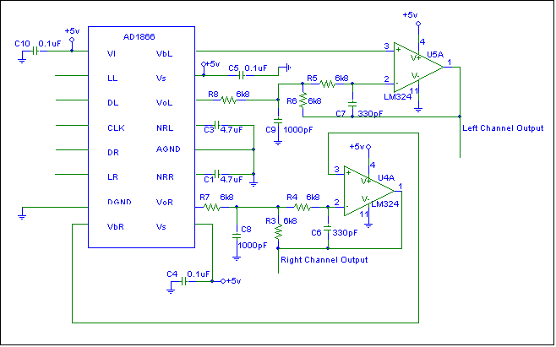

Figure 2: Interfacing the AD1866 to the 50-pin AUX

The circuit is essentially the DAC channel outputs connected to RC low-pass (anti-alias) filters to filter out the frequencies above upper frequency limit of humans (20 kHz). It is usual to filter the output before amplification or have an integrated filter/ amplifier afper the DAC stage.

According the datasheet for this device, the minimum voltage that will be recognised as a high on one of the input pins is 2.4V. The maximum voltage for a digital low on one of these inputs is 0.8V. The power supply pins V_{L} and V_{S} are both specified to work between 4.75V and 5.25V, though 5V is typical. These supplies may operate at voltages as low as 3.5V. The power supply must therefore supply a voltage of at least 4.75V in order to meet the specified voltage needed by the DAC. How LL, DL, CLK, DR, LR, DGND and all +5V and ground supplies are connected to the FPGA will be discussed in the power supply design section. The channel outputs could either be connected to a single 3-pole jack socket, separately to two 2-pole jack sockets, or to the speakers directly.

Table 1 describes each of the AD1866’s 16-pins.

Pin# | Pin Name | Description
1 | V_{L} | Digital Supply (+5V)
2 | LL | Left Channel Latch Enable Pin
3 | DL | Left Channel Data Input Pin
4 | CLK | Clock Input Pin
5 | DR | Right Channel Data Input Pin
6 | LR | Right Channel Latch Enable Pin
7 | DGND | Digital Common Pin
8 | V_{B}R | Right Channel Bias Pin
9 | V_{S} | Analogue Supply (+5 V)
10 | V_{O}R | Right Channel Output Pin
11 | NRR | Right Channel Noise Reduction Pin
12 | AGND | Analogue Common Pin
13 | NRL | Left Channel Noise Reduction Pin
14 | V_{O}L | Left Channel Output Pin
15 | V_{S} | Analogue Supply (+5 V)
16 | V_{B}L | Left Channel Bias Pin
Table 1: Pin Descriptions for AD1866

The frequency of the input clock is given by the equation:

Frequency = sampling frequency * number of bits per sample * over-sampling rate

The sampling frequency is the value in the MP3 header.

Amplifier and Speakers

The amplifier converts the analogue signal from the DAC to the chosen user sound “loudness” value, which must be between the positire and negative supply voltage rails of the speakers. Two 5-10 Watt (W) Root Mean Squared (RMS) passive speakers will produce a discrete sound without amplification. Two 20-50 W RMS active speakers will produce a very loud sound. As stated previously the amplifier may be part of the speaker unit(s) or may be a stand-alone unit. We have chosen active/amplified speakers for several reasons. First, it simplifies the custom hardware design by having a prefabricated speaker and amplifier unit. This also reduces risks and has the advantage of producing a higher quality product than might be possible if both the speakers and amplifiers are built from components of the shelf. Finally, it enables greater reuse. The same speakers that are used to play sound via the sound card in the initial project stages can be reused in this later stage leading to lower development costs.

Power Supply

Ultimately, the filter and the digital to analogue converter must be connected to the FPGA in order to convert the samples to audio output. The RC1000-PP from Celoxica supports many input/output standards. These include Low Voltage TTL (LVTTL), 3.3 Volt Low-Voltage CMOS (LVCMOS 3.3V), 2.5 Volt Low-Voltage CMOS (LVCMOS 2.5V) and 3.3 Volt PCI (33MHz, 3.3V and 66MHz, 3.3V). All of the standards listed are appropriate for the input signals to the DAC but none meets the criteria for at least 4.75V at the positive power supply pins of the DAC. It was therefore necessary to design an interface to convert these low voltages to over 4.75V DC. A DC-DC converter was chosen for this interface. The part used had to support inputs from 2.5V to 3.3V. It also had to be low cost. The MAX619 step-up charge-pump DC-DC converter from MAXIM is such a chip. It converts voltages from 2.0V to 3.6V to an output between 4.8V and 5.2V with minimal interfacing components (only four external capacitors). Not only is the chip inexpensive (£2.32 from Farnell), the extra components required are also very low cost. The chip also features a shutdown pin (SHDN) that places the device in a low-power shutdown mode and zeros the output voltage, effectively turning off any connected circuitry. The output current supply is more than adequate for the application. The signal inputs of the DAC and the DC-DC converter are all CMOS compatible so LVCMOS 3.3V is the preferred output standard from the FPGA. Figure 3 shows a schematic of the power supply interface. The input voltage is direct from the FPGA and so is the SHDN pin’s voltage. The pins requiring 5.0V in the filter and DAC are connected to the OUT pin of the MAX619. The other input pins of the DAC are connected directly to LVCMOS pins of the FPGA.

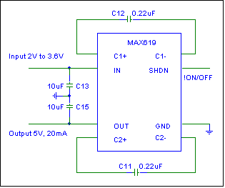
Figure 3: Power Supply Design

Conclusion

In this section a high level and a detailed schematic design level of the custom audio interface was described. The power supply to the filter and the digital to analogue converter are from the FPGA via a DC-DC step-up converter. The clock signal, left and right channel data, and left and right channel enable signals of the DAC are direct from LVCMOS 3.3V configured pins of the 50 pin AUX header of the FPGA. Some processing is required before data is sent to either channel of the DAC. This is essentially an interpolation algorithm that has yet to be decided. The system reuses the speakers from earlier stages in the project’s lifecycle in order to reduce cost and simplify design. These speakers have an internal amplifier for volume. The speakers connect to the filter via a single 3-pole audio socket. Table 2 shows the major components used in the design and the cost of each of these components.

Part Description | Manufacturer | Part Code | Supplier | Supplier Code | Price (£)
Dual Op Amp | EBV ELEKTRONIK | LM358D | Farnell | 300-3681 | 0.27
DC-DC converter | MAXIM | MAX619 | Farnell | 702-614 | 2.32
Dual Audio DAC | Analog Devices | AD1866 | Farnell | 595-020 | 19.03
Table 2 : Major Parts List

Appendix:

Single Supply Dual 16-bit Audio DAC, AD1866 Data Sheet, Analog Devices, Rev. 0.

MAXIM Regulated 5V Charge-Pump DC-DC Converter Data Sheet (MAX619), MAXIM, Rev 2, 5/96

To be added:

Proper references, better explanation of why LVCMOS is better than other I/O standards for this application.

