DEEP-3 Graphic User Interface

This section aims to describe some major issues associated with the graphical user interface (GUI) such as the role of user interface within the system, the GUI design steps, and factors that need to be taken into consideration when designing the DEEP-3 user interface.

-- The GUI analysis (currently stored in university computer) will be added here

DEEP-3 User Interface Overview

The DEEP-3 user interface consists of two stages, the first stage is represented by a SIGN ON menu as shown below. The second stage is the DEEP-3 system menu (as shown in figure 3).

All users of the DEEP-3 system must be registered, once an account has been opened, the user will be given a user name and password, which will enable he/she to gain access to the DEEP-3 system.

The user is required to type in the user-name and password every time he/she wishes to use the system, the information entered by the user is then verified with a database. If the information entered is correct, the user will be able to log on to the system, otherwise an error message will be displayed.

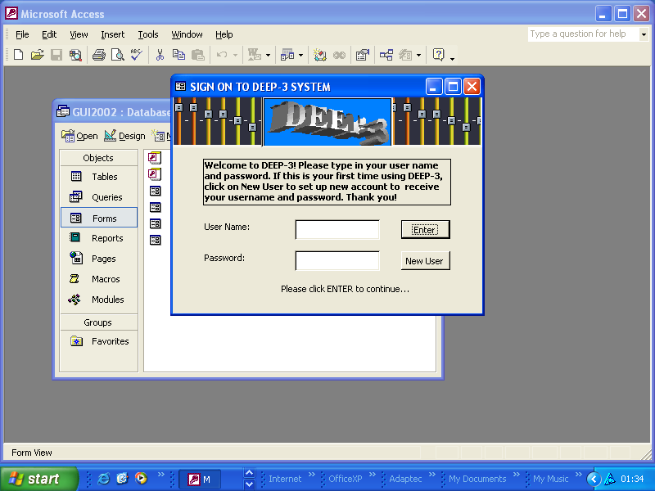
Figure 1. The Sign On Menu of the DEEP-3

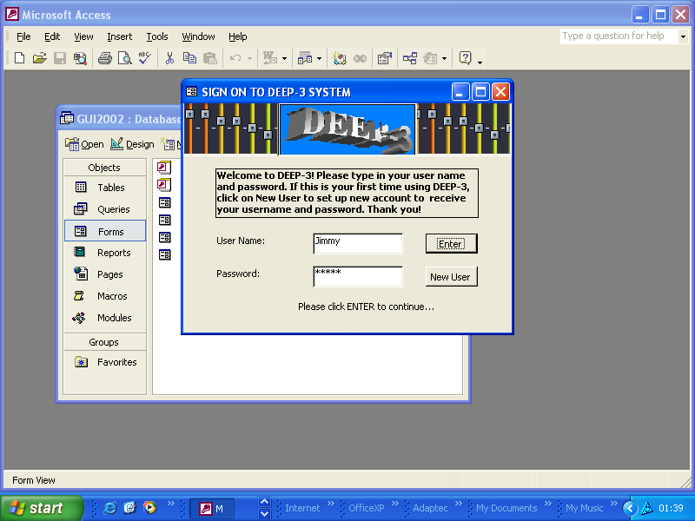
Figure 2. The Signing On Process

When valid user-name and password have been entered, the user will be able to access theDEEP-3 main menu. In this menu, the user can play the encrypted MP-3 files with all the standard features such as player options, audio mode selector, create list of files to be played or save files.

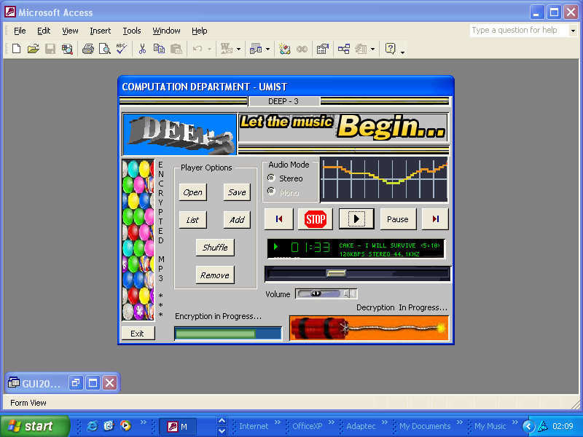
Figure 3. The DEEP-3 System Menu

