DEEP-3 System Architecture

This chapter aims to describe the DEEP-3 system architecture, this includes a detailed description of hardware and software components such as Handel-C, FPGA chip and RC1000 board from Celoxica™.

The DEEP-3 system architecture is shown in figure 1. The system consists of four main units, a general-purpose processor, a storage device, local memory and an RC1000 board, which supports the XILINX® Virtex™ XCV1000 FPGA.

Host CPU

(x86)
RC-1000 Board
(FPGA – Memory)
Storage Device
Memory (RAM)
IDE-Bus
PCI 32 - Bus
PCI-Bus

Sound Card

DMA

Speakers
Line In

Figure 1 – DEEP-3 System Architecture

Host CPU is a standard general-purpose instruction-set processor, which can perform a variety of tasks. The host CPU to be used with DEEP-3 is a standard x86 processor. This can either be an Intel Pentium MMX or Celeron processor and thus 100% compatible to a standard PC desktop workstation. All standard operating systems can be used, in particular Windows NT and Linux, without the need to adapt drivers or I/O handlers, etc. The CPU module allows to have the complete FPGA development tool-set be run on the target system, as well as the application itself. The XILINX® Virtex™ XCV1000 FPGA and RC1000 board act as co-processor, accelerating time and resource consuming parts of an application, and providing high I/O bandwidth. Moreover, the CPU is needed for control, when task switching and re-configuration of FPGA is desired. Additionally, high precision floating point operations that are too much resource consuming on FPGA, may be carried out in the CPU.

Local Memory is also known as random access memory (RAM), this memory can be accessed directly by the system processor.

Storage Device is used to store data such as program source code or audio files, this device is often referred to as a hard-disk. The system processor can read and write to this hard-disk using the IDE-bus.

Sound Card is an expansion board that enables a computer to manipulate and output sounds. Sound cards enable the computer to output sound through speakers connected to the board, and also to record sound input from a microphone.

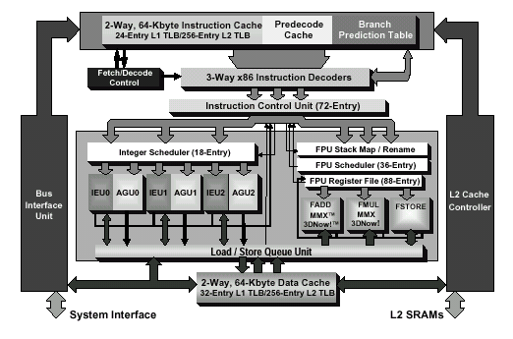
The host CPU that’s being used for this project is the x86 family AMD Athlon processor. Figure 2 shows the architecture of the ADM Athlon™ processor.

Figure 2. AMD Athlon™ Processor Block Diagram

The AMD Athlon processor’s micro-architecture is designed to support the growing processor and system bandwidth requirements of emerging software, graphics, I/O, and memory technologies. The AMD Athlon processor's high-speed execution core includes multiple x86 instruction decoders, a dual-ported 128-Kbyte split level-one (L1) cache, three independent integer pipelines, three address calculation pipelines, and the x86 industry's first superscalar, fully pipelined, out-of-order, three-way floating-point engine. The floating-point engine is capable of delivering 2.4 gigaflops (Gflops) of single-precision and more than 1 Gflop of.double-precision floating-point results at 600 MHz for superior performance on numerically complex applications.

Another piece of important hardware shown in the system architecture is the RC-1000 board. The RC-1000 board is a standard PCI bus card equipped with a XILINX® Virtex ™ family BG560 part with up to 2 million system gates. It has 8Mb of SRAM directly connected to the FPGA in four 32-bit wide memory banks. The memory is also visible to the host CPU across the PCI bus as if it were normal memory. Each of the 4 banks may be granted to either the host SRAM on the board. It is then accessible to the FPGA directly and to the host CPU either by DMA transfers across the PCI bus or simply as a virtual address. The board as shown in figure 2, is equipped with two industry standard PMC connectors for directly connecting other processors and I/O devices to the FPGA, a PCI-PCI bridge chip also connects these interfaces to the host PCI bus, thereby protecting the available bandwidth from the PMC to the FPGA from host PCI bus traffic. A 50-pin unassigned header is provided for either inter-board communication, allowing multiple RC1000s to be connected in parallel or for connecting custom interfaces. The support software provides Linux (Intel), Windows® 98, NT® 4.0+, and Windows 2000 drivers for the board together with application examples written in Handel-C. The board may also be programmed using the XILINX ® Alliance Series and Foundation Series software tools and other EDA tools.

Figure 3. Functional Block Diagram of RC1000
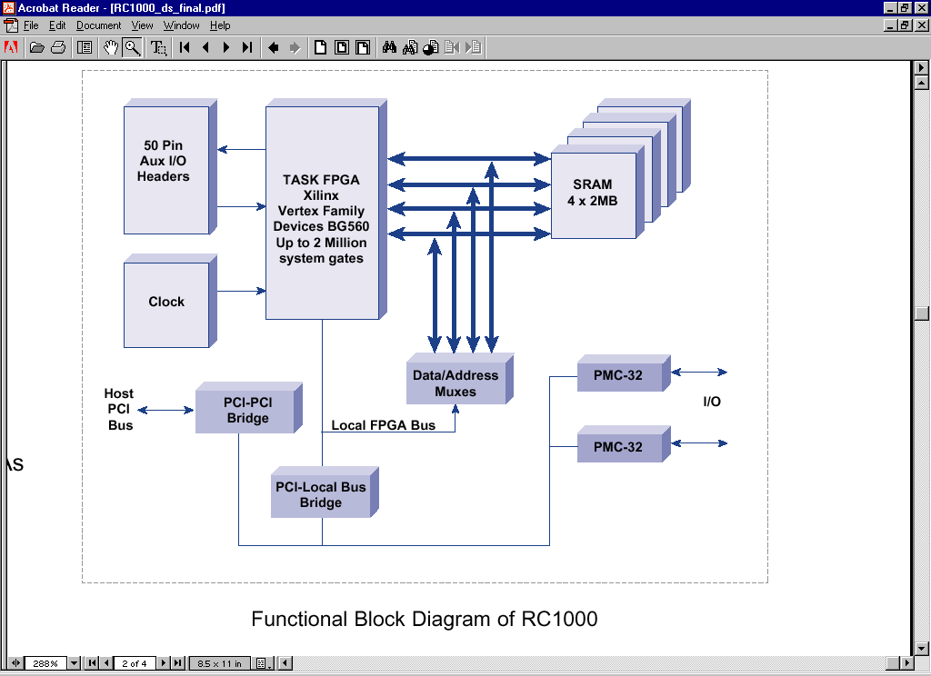

http://www.amd.com/usen/assets/content_type/white_papers_and_tech_docs
http://www.windriver.com/pdf/RC1000_ds_final.pdf

